**Lab1 CSCI-5160 Spring 2025**

**Introduction to Enterprise Networks**

Lab 1

Learning about Switches

**Spring 2025**

Lab1 CSCI 5160 Spring 2025

**OBJECTIVES**

1. **Learn how to perform basic switch configuration & troubleshooting including.**
   1. **Review basics for the switch password assignment and IOS navigation**
   2. **How to activate/deactivate a Port**
   3. **How to change the Speed and Duplex Mode on a Switch port**
   4. **How to verify the MAC addresses of computers connected to a specific port**
2. **Learn how to secure a Switch port so that only a specific user/device can connect.**
3. **Learn how to Create VLANs within a single Switch**
4. **Learn how to create VLANs across multiple Switches**
5. **Learn how to achieve Inter-VLAN communication using Trunking Protocols such as 801q and ISL**
6. **Configure VLAN Trunking Protocol (VTP) to manage multiple switches from a single one**
7. **Review the usage of Spanning Tree Protocol and how the switching environment behaves in the event of a network failure**
8. **Learn how Rapid Spanning Tree Protocol (RSTP) or IEEE 802.1W is essential for faster convergence**
9. **Learn to increase the efficiency of a redundant network (PVST)**
10. **Learn about optional STP features like “Portfast” and “Etherchannel”**
11. **Sniff packets from your network.**

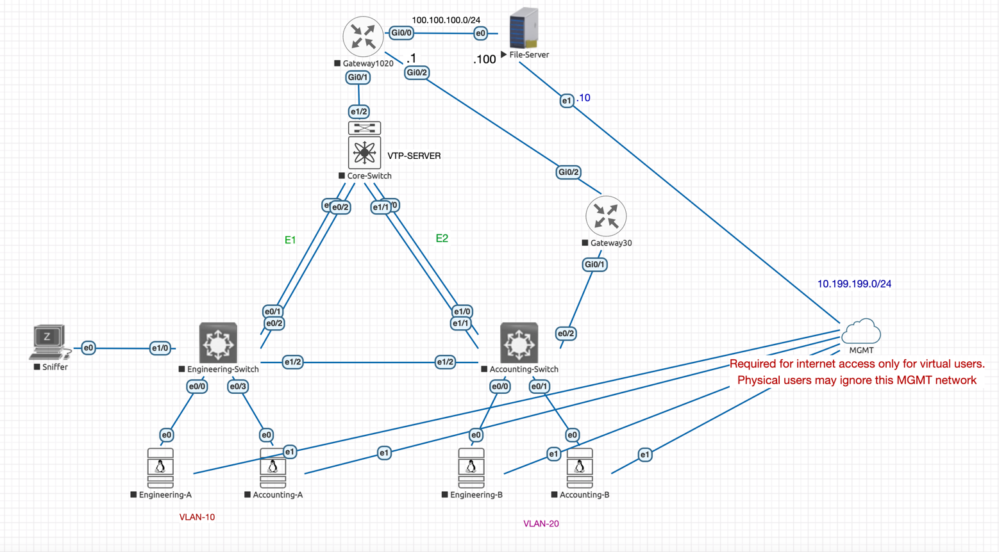

**Scenario:**

A company named **TechCorp** has two departments: **Engineering** and **Accounting**. Both departments need access to a centralized server, which hosts separate directories for each department. The server is located on a separate network (All required routes are configured for this lab), and the two departments are located on different VLANs. Inter-VLAN communication should be restricted except for accessing the server to ensure security and proper isolation.

**Objectives:**

1. **Basic Switch Configuration:**
   * Set up basic switch configurations, setup SSH on the Engineering-Switch and the Accounting-Switch including password protection and IOS navigation.

**Engineering-Switch(Switch 1) -**

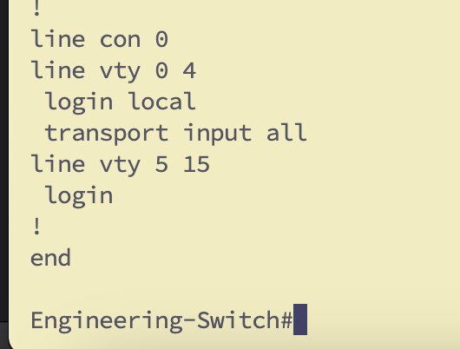

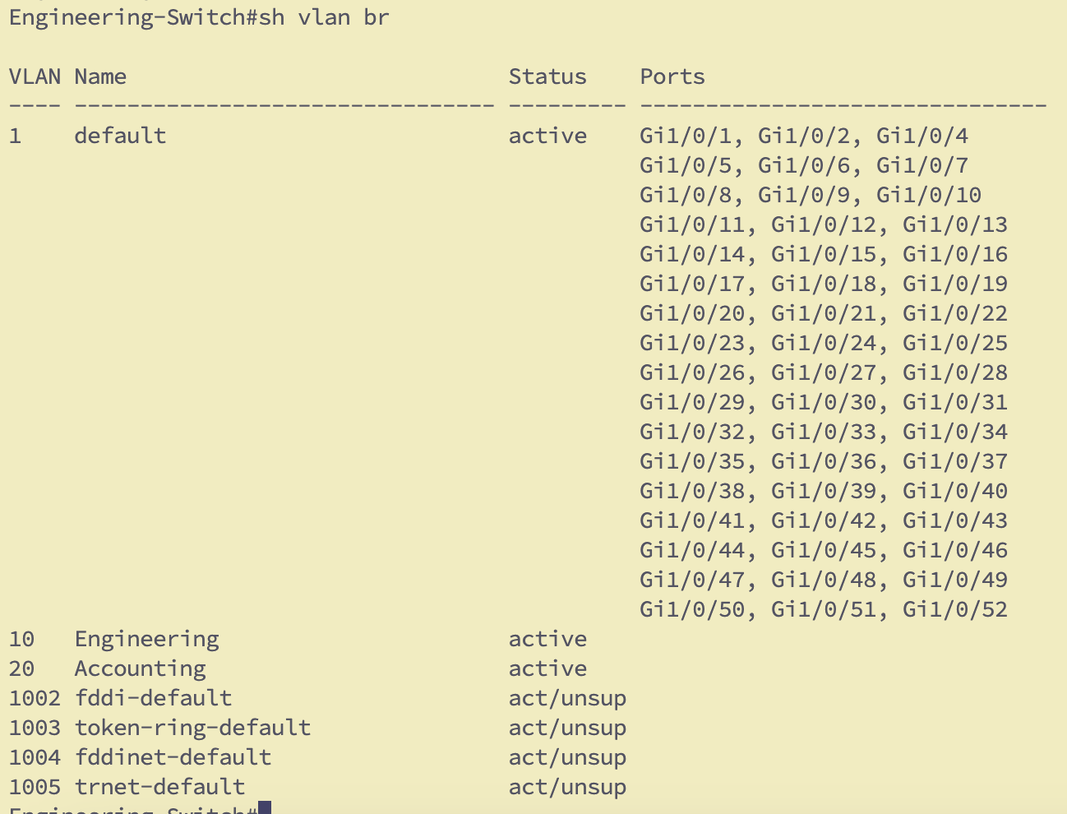

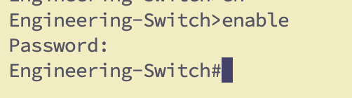

**Accounting-Switch(Switch 2) –**

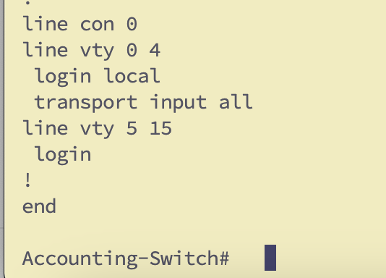

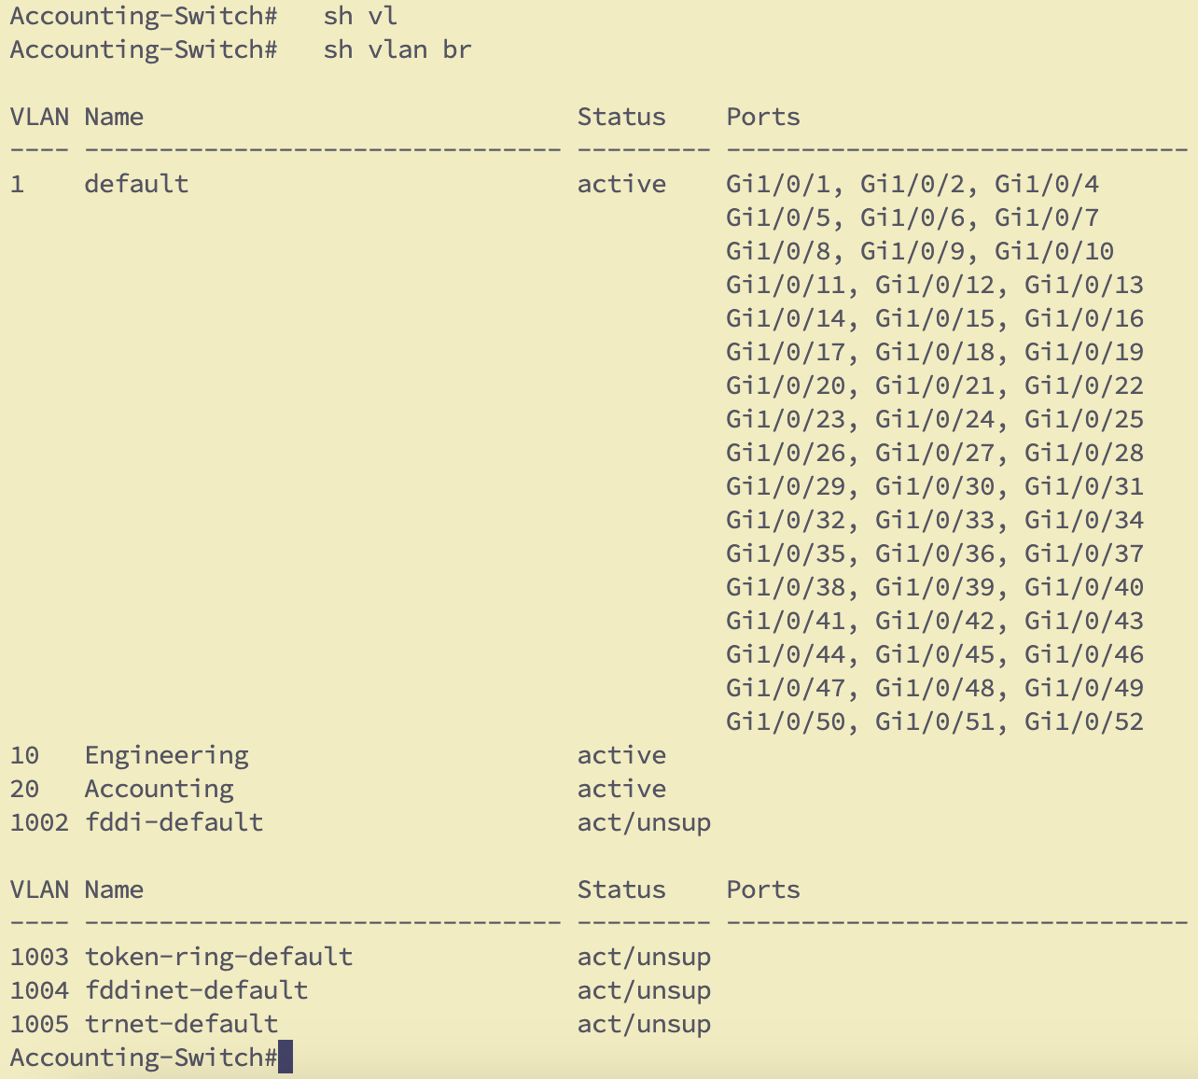



* + OUTCOME: PCx should be able to SSH to all the switches in the network

Report the commands with screenshots

**Engineering-Switch(Switch 1) –**

**Commands** – ssh -oHostKeyAlgorithms=+ssh-rsa [atul@10.0.1.2](mailto:atul@10.0.1.2) -oKexAlgorithms=+diffie-hellman-group1-sha1



**Accounting-Switch(Switch 2) –**

**Commands** - ssh -oHostKeyAlgorithms=+ssh-rsa -oKexAlgorithms=+diffie-hellman-group1-sha1 -oCiphers=aes128-cbc,3des-cbc,aes192-cbc,aes256-cbc [atul@10.0.1.3](mailto:atul@10.0.1.3)

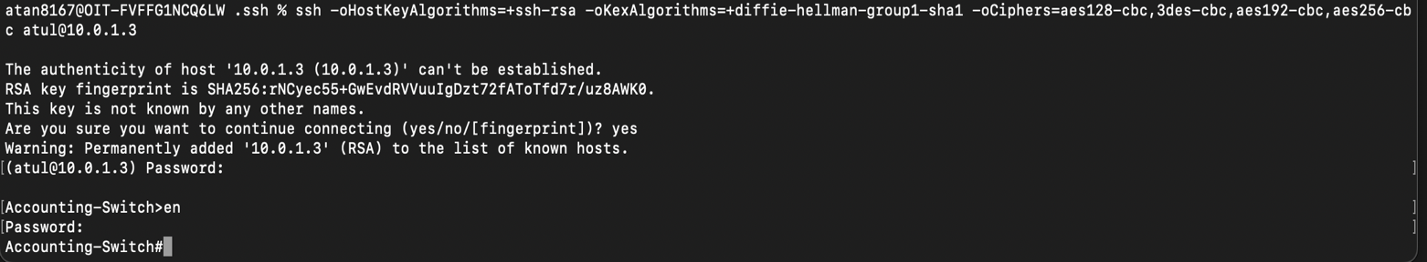

1. **Default Switch Connectivity Test**
   * Activate and deactivate specific switch ports connected to each client as needed.

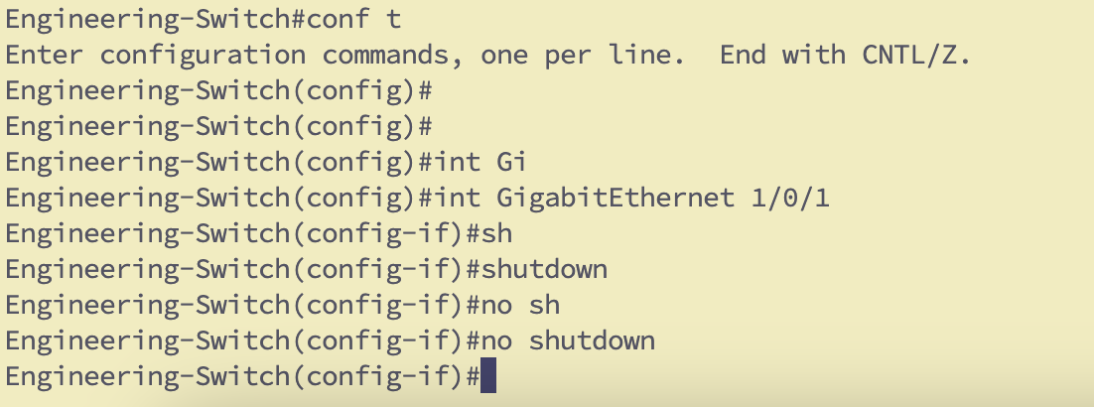

* + Assign IP addresses of your choice (/24) and ping from one client to another using the default VLAN.

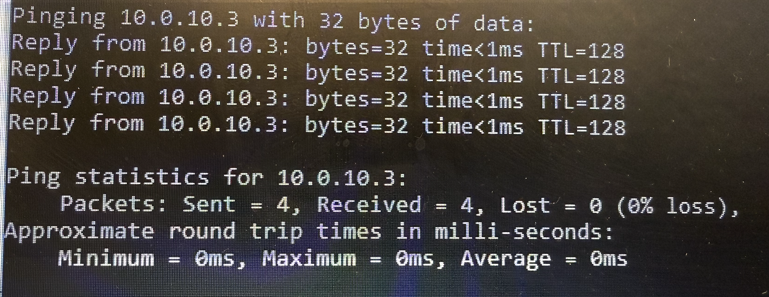

* + Show the interfaces status on both switches. Use ‘show interface status’ or ‘show ip interface brief’

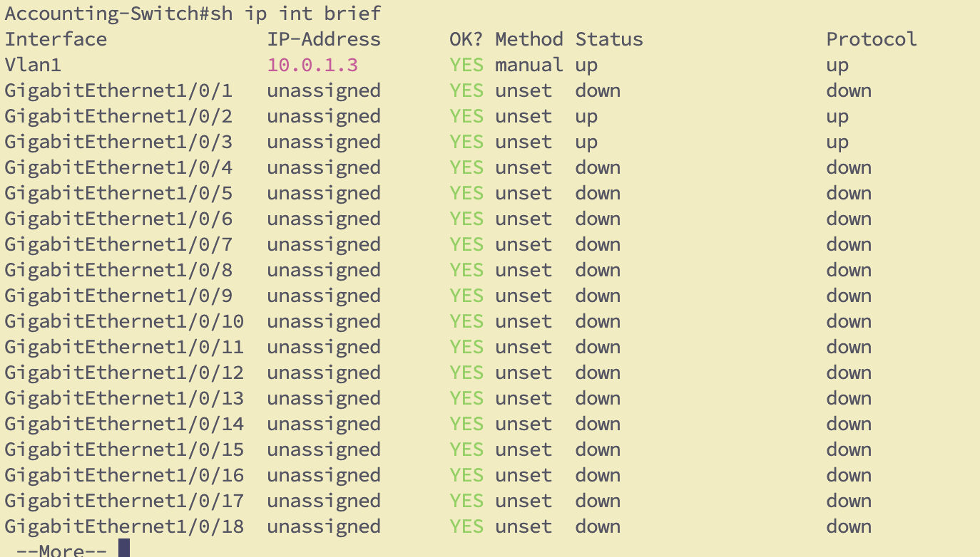

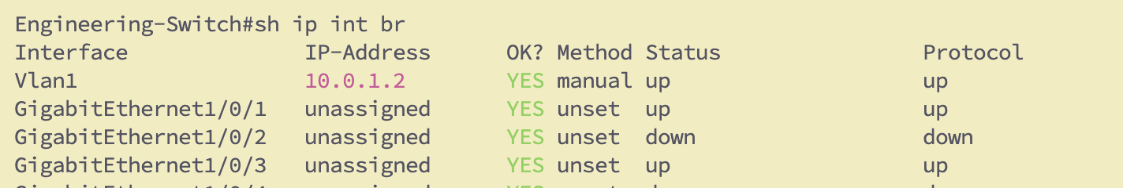

* + Change port speed to 10Mbps and duplex mode to half for the port connected to Engineering-A.

Turn on debugging and report any changes you see when the port is in half or full duplex mode

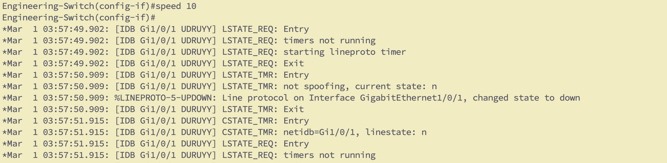

* + Verify connected devices using show mac address-table. On both switches.
  + OUTCOME: See how mac addresses are learned by all switches, for all systems connected.

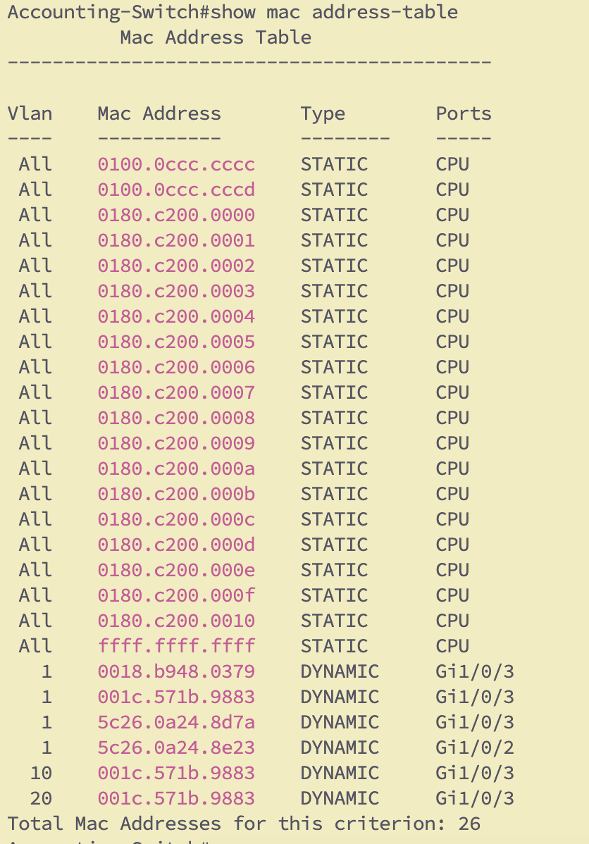

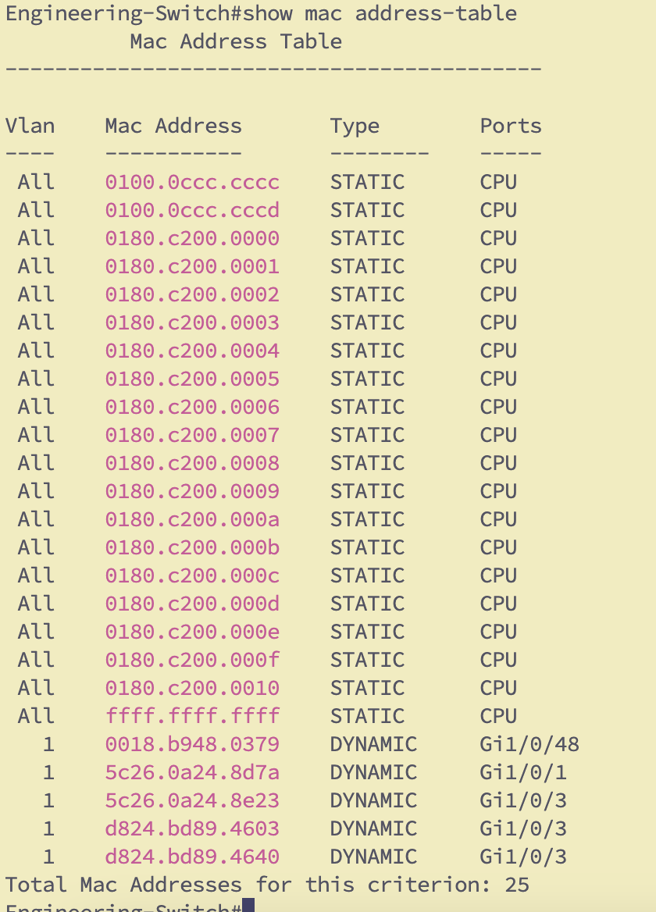

1. **Port Security Configuration:**
   * Configure port security on ethernet0/3 on the Accounting-Switch to ensure that only Accounting-B user can connect to this port.  
     First, add the mac-address of Accounting-B manually and once again configure in such way that the mac-address is read automatically from the switch.





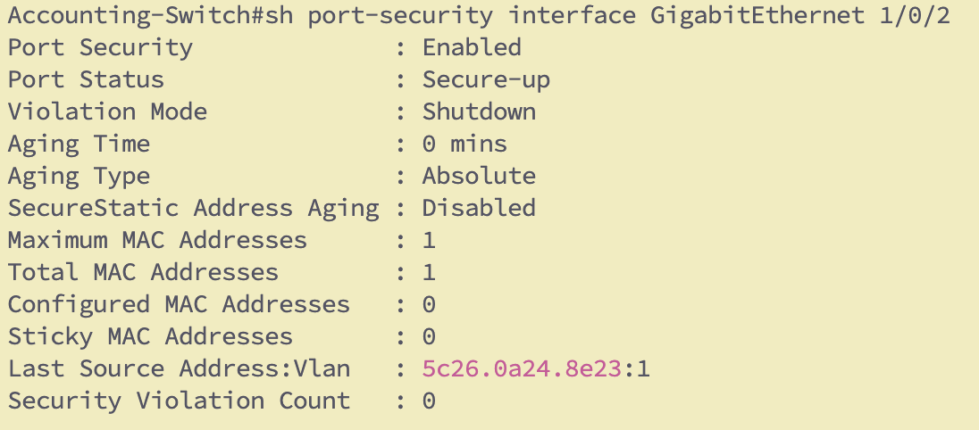

* + Add a new client and test the security policy by swapping cables between devices and verify the console messages when unauthorized devices attempt to connect.

***SAVE your config on the switch and clients then shut down the nodes before swapping cables.

Verify that your port security works, and its reversible once approved system is restored.

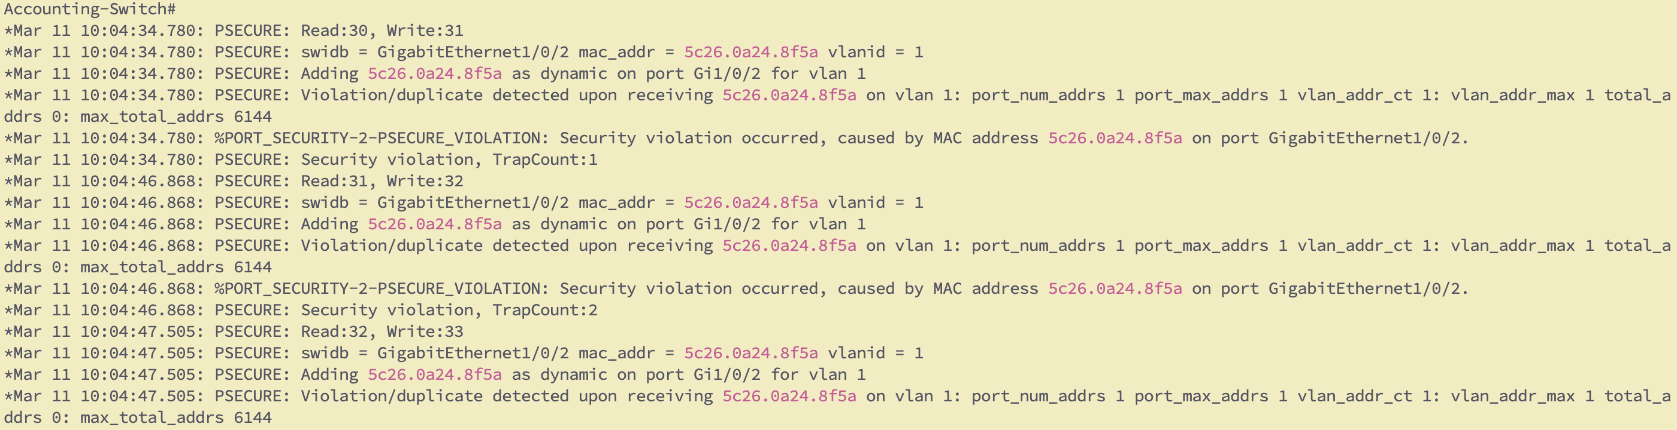

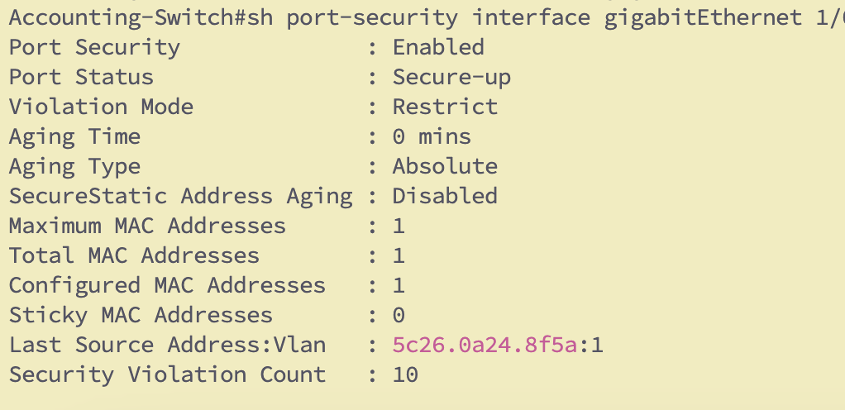

* OUTCOME: Prove that only a particular mac-address/system can connect to a unique physical port, and if you connect a different computer, port with stop its functionality



Report the commands you used and the screenshots of the debug messages.

Restore network connectivity without reconnecting equipment. (**Adjust security policy only)**

1. **Switch VLAN Configuration:**
   * Create VLANs for each department on each switch:
     + VLAN 10: **Engineering**
     + VLAN 20: **Accounting**

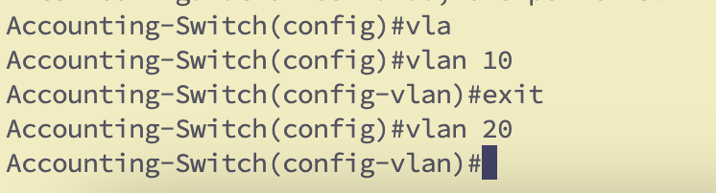

* + Assign the ports connecting to each department’s devices to the appropriate VLAN.

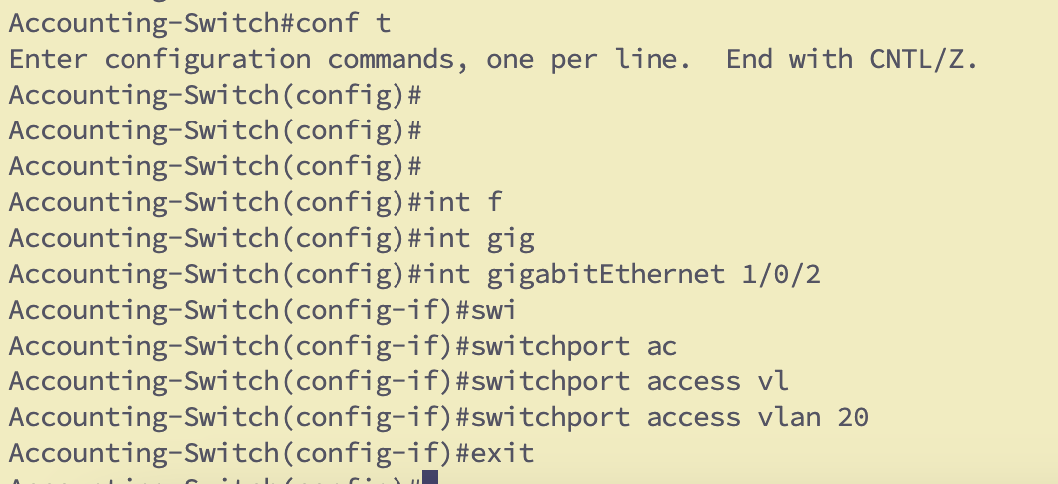

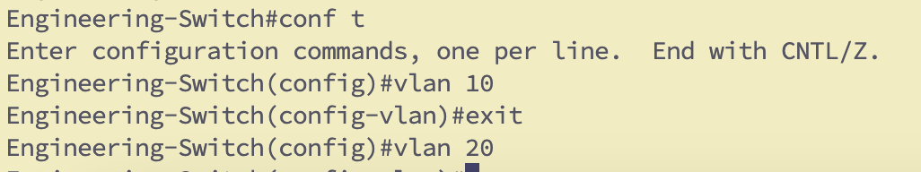

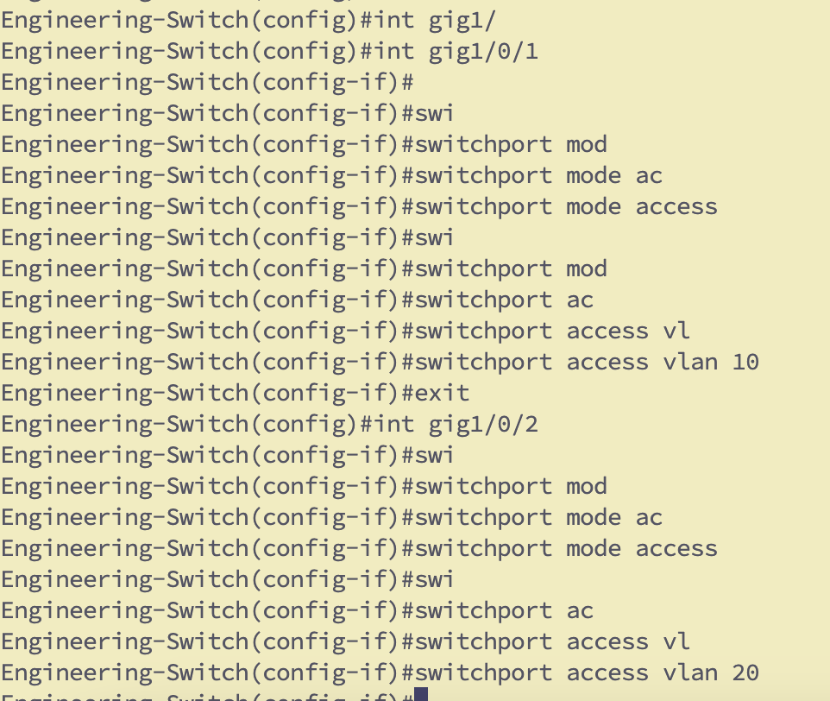

* + Configure the single port between the two switches (e1/2) as a trunk to allow communication with both VLANs.

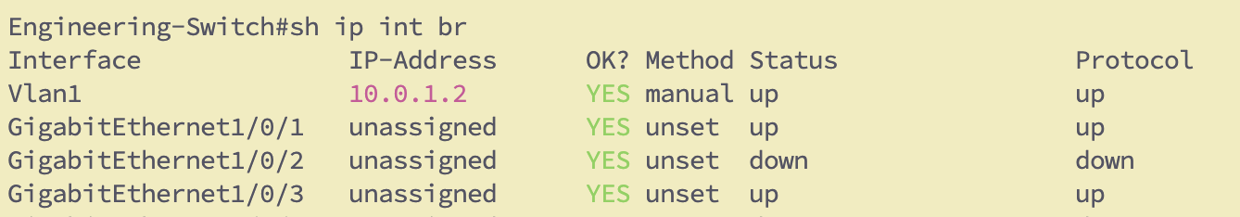

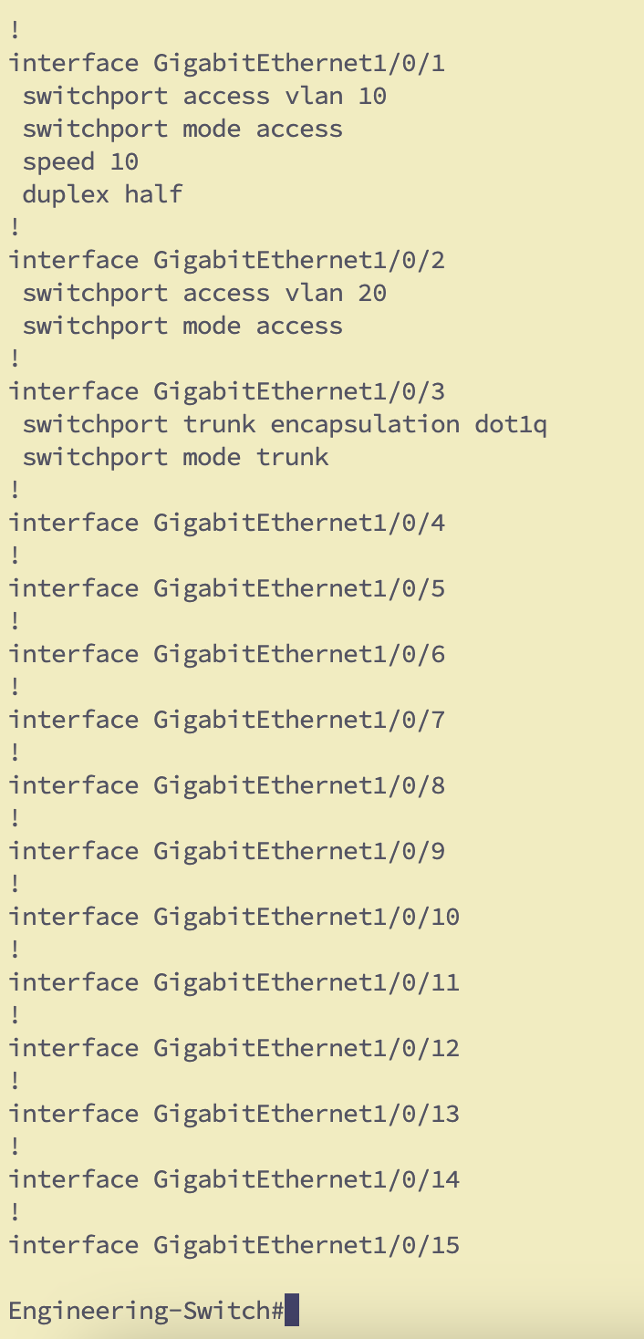

* + Which trunking encapsulation was supported by both Switches by default? What other options are available? Use all variants and test end-to-end connectivity.
  + Verify that devices within the same VLAN can communicate, but devices from different VLANs cannot.

When devices were in same VLAN 10 –



When Vlan change to 20 for the device –

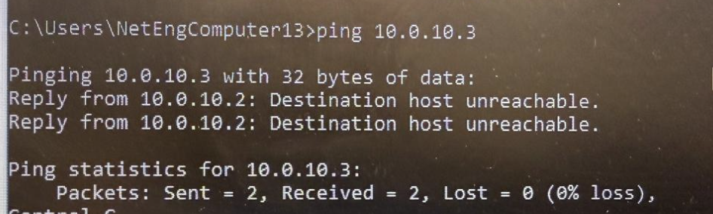

* + Ping from Engineering to Engineering

We could when both the devices were in same VLAN (Refer Above screenshot)

* + Ping from Engineering to Accounting. What is the result?

I changed the host port and validated it cannot ping as above screenshot.

* + OUTCOME: Verify VLAN isolation for each respective department. Users of each department should only be able to ping their members

Verified as per screenshots – only within the same VLAN

Report the commands + screenshots

1. **Router-on-a-Stick for Inter-VLAN Communication:**
   * Use the router to enable inter-VLAN communication only for the purpose of accessing the server, and pinging across approved departments
   * Configure sub-interfaces on the Gateway1020 for VLAN 10 and VLAN 20, each with a different IP address in their respective subnets.

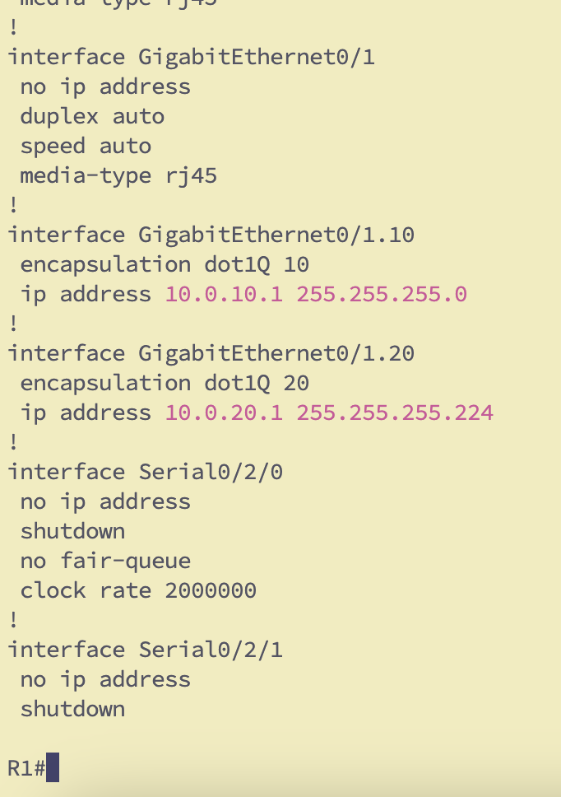

* + Use a /24 for Engineering and a /27 for accounting.

Refer to above screenshot

* + Configure one port from the core switch to the Gateway1020 to enable inter-vlan connectivity. (Access or Trunk?)

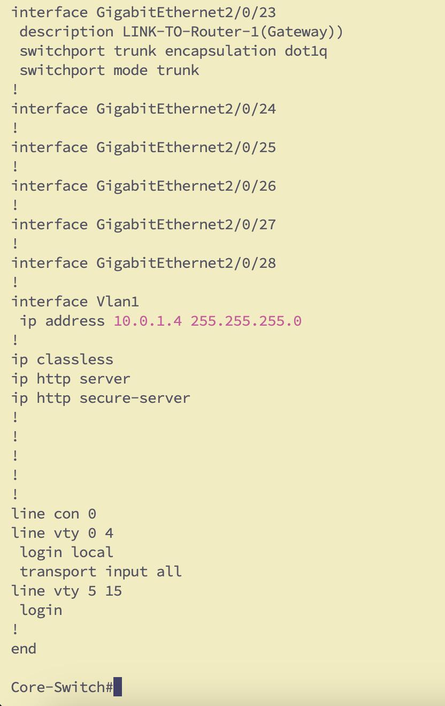

* + Ensure that the router provides access to both Engineering and Accounting to the Fileserver through their respective default gateway.

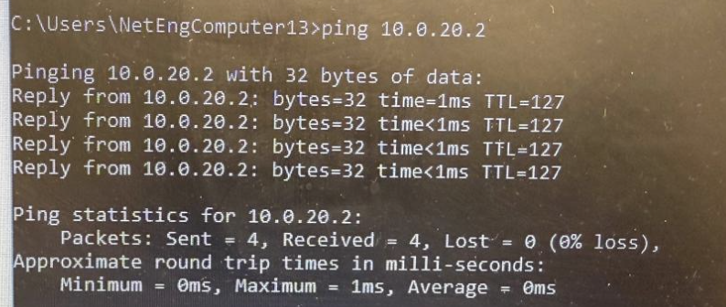

* + Do you need to worry about using the same IP addressing on Different VLANs? Why or why not?

No, as different VLAN will be using different subnet altogether.

* + OUTCOME: Engineering and Accounting departments should be able to reach their respective default gateways and visit the Fileserver.

Screenshot below is from Host 1 which is connected to switch 1 in engineering port 1 and the 10.0.20.2 is assigned to host 2 connected to switch 2 in Accounting VLAN port 2.



Report the commands you used on the core switch and the DG for inter-vlan configuration

1. **Multiple Simultaneous Switch VLAN Configuration using VTP (** **):**
   * The core switch provides access to the DG

*You can add new vlans to the server and propagate them to other switches in the network without having them configured manually on other switches.

* + Configure the core switch as a VTP server, and the Accounting-Switch as a VTP client
  + Leave the Engineering-Switch as transparent.

**Core-Switch –**

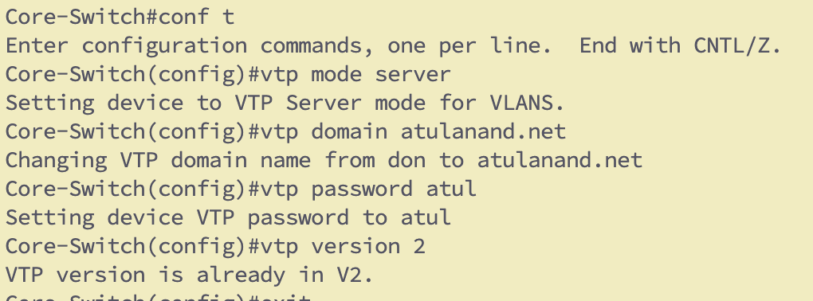

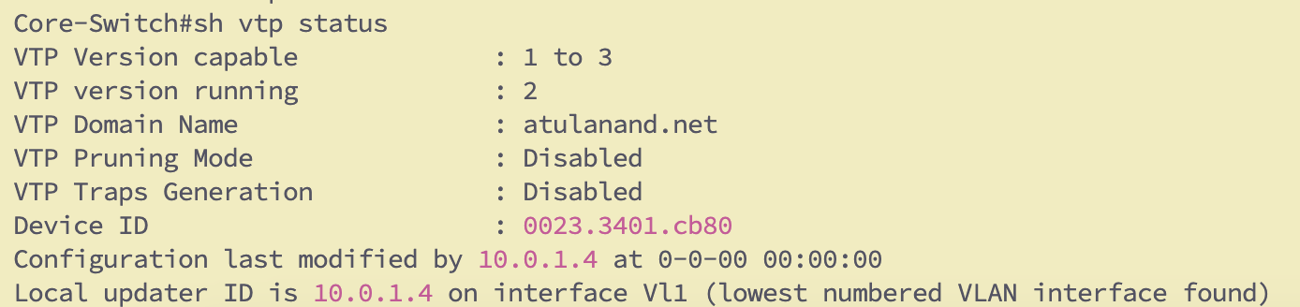

Accounting-Switch-

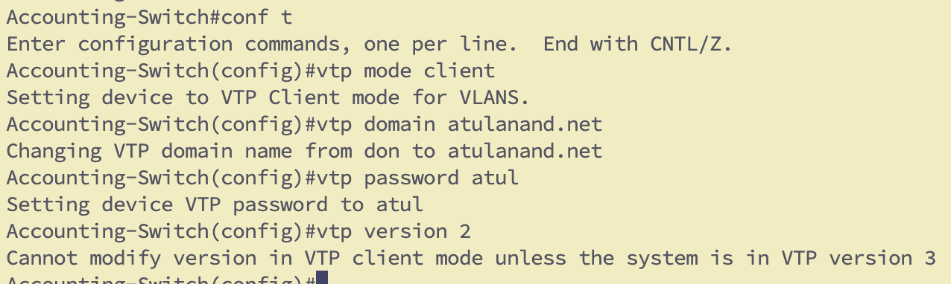

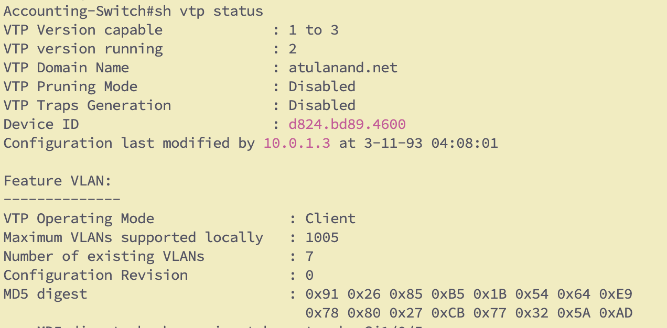

Engineering-Switch -

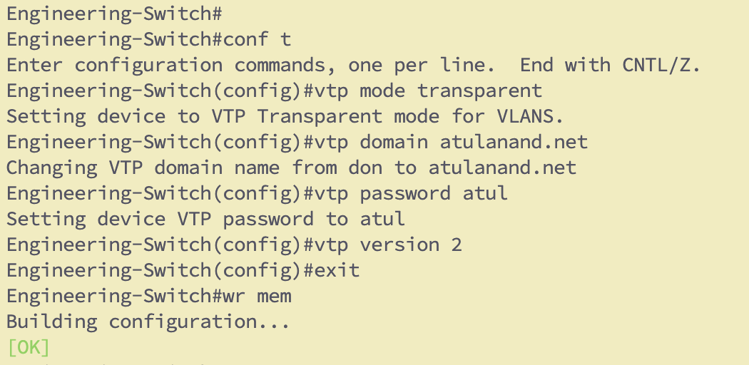

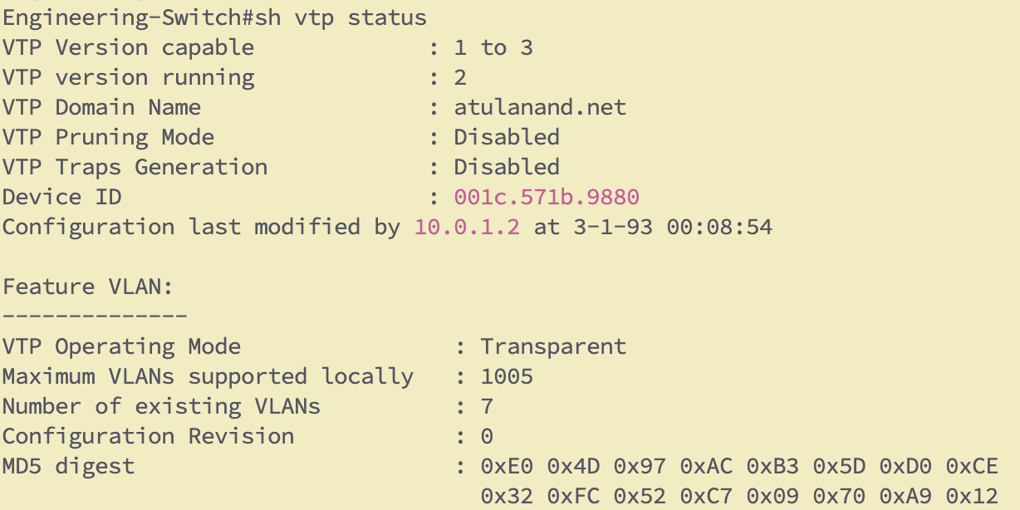

* + Add a new VLAN (30) on the core switch and make sure that the new VLAN is updated automatically on the other switches.

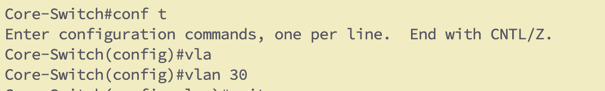

Replicated on Accounting –

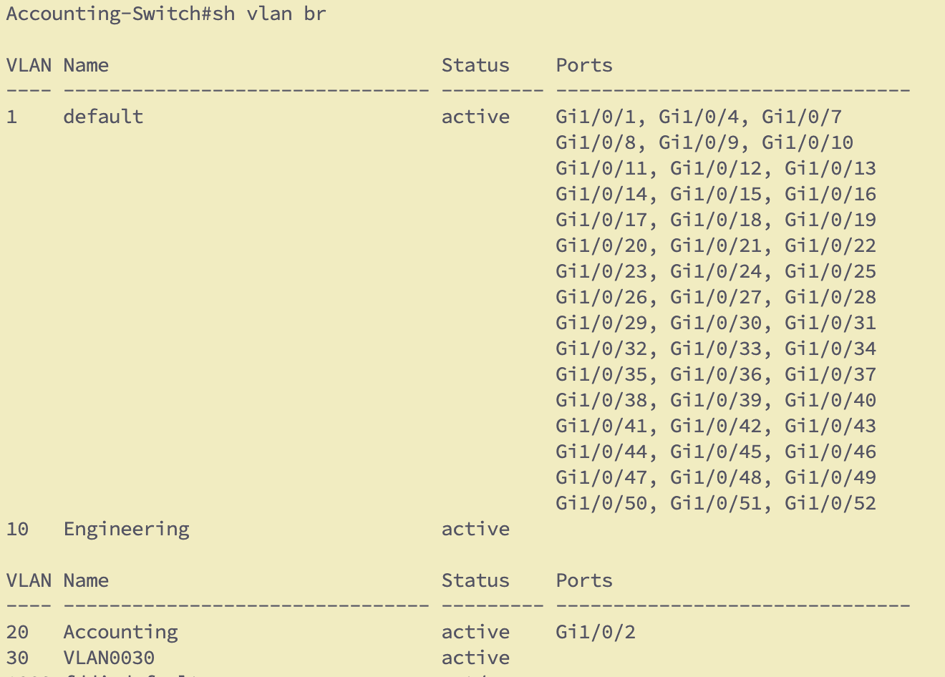

* + Configure different versions and password protection for the VTP.

I verified with version 1 and 2 on core and accounting switches.

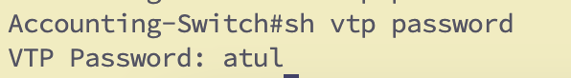

* + Configure trunk ports between the switches.

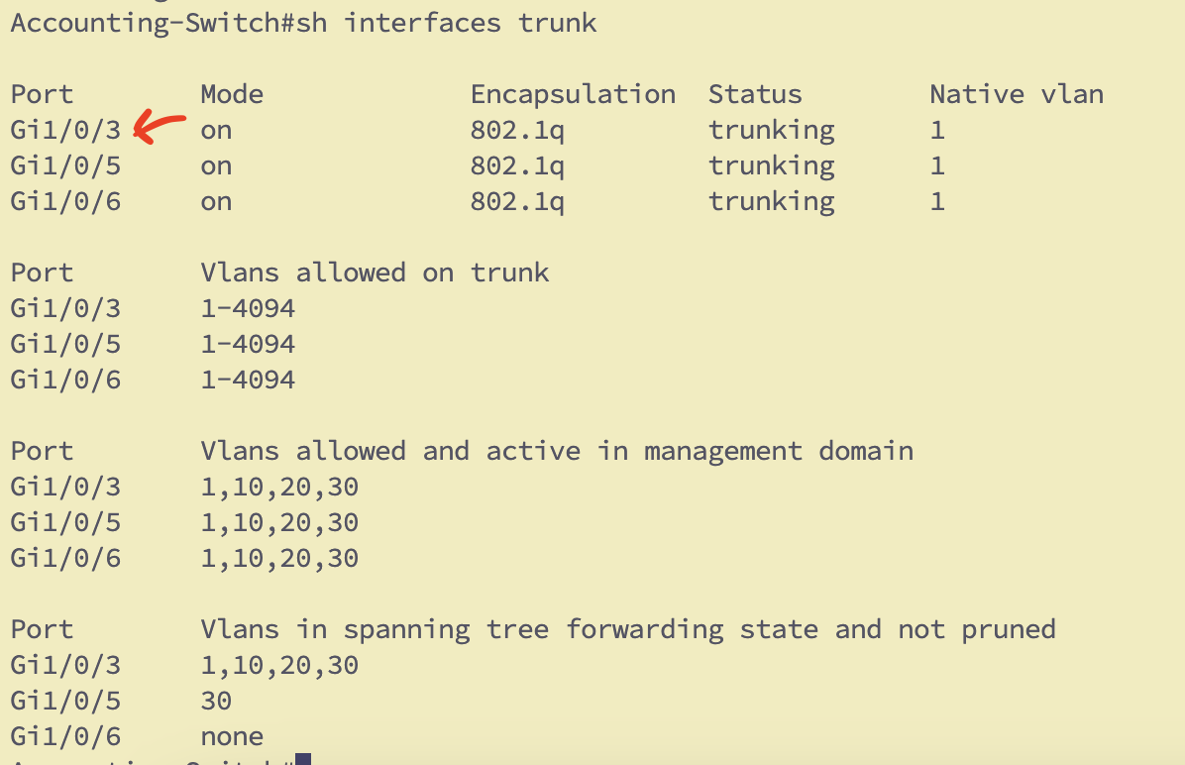

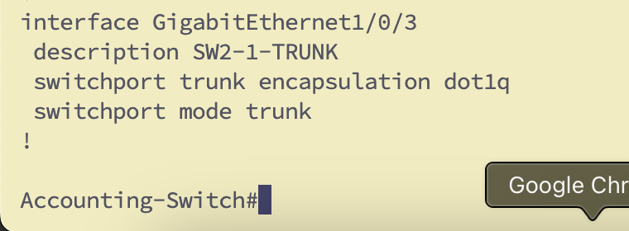

* + Change the name of Accounting VLAN to HumanRes ONLY on the core switch. Verify that the Accounting-Switch adjusts to the new changes automatically as result of VTP.   
    Report from Switch IOS VLAN name propagation

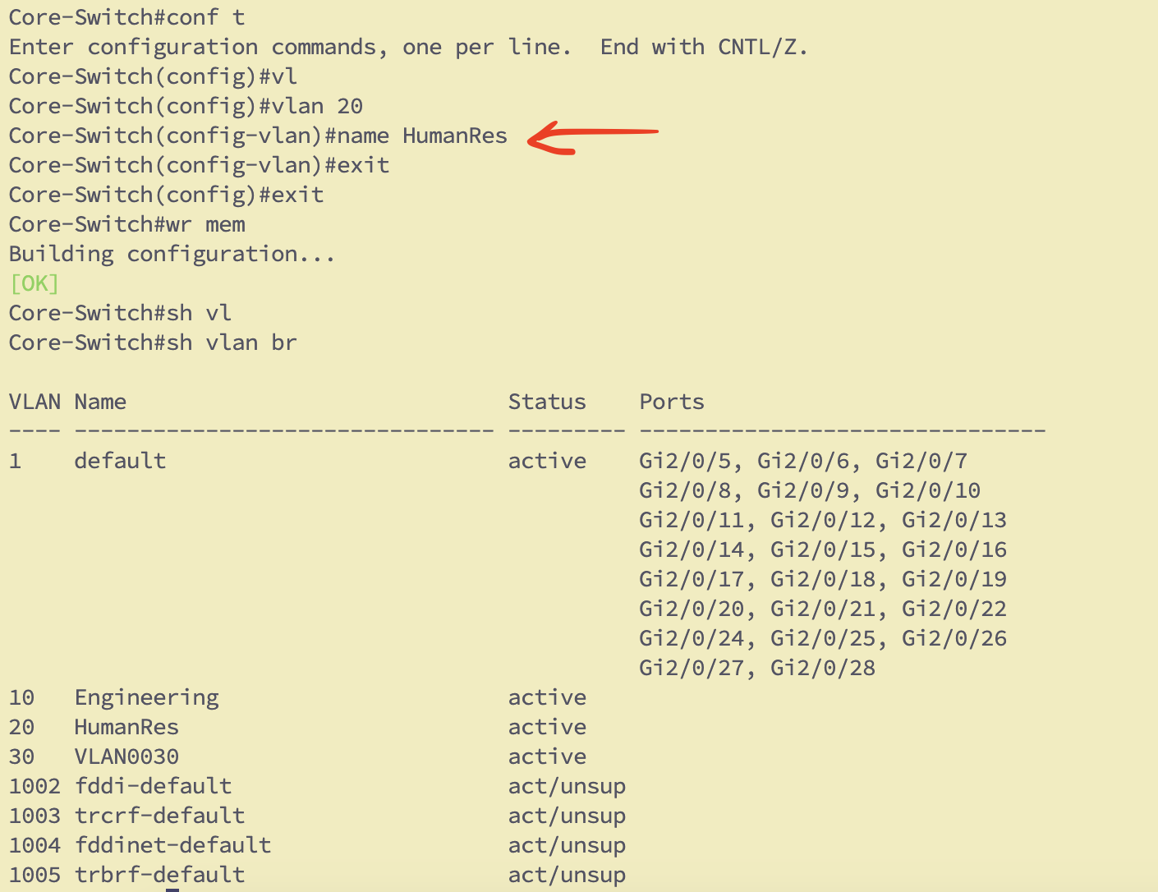

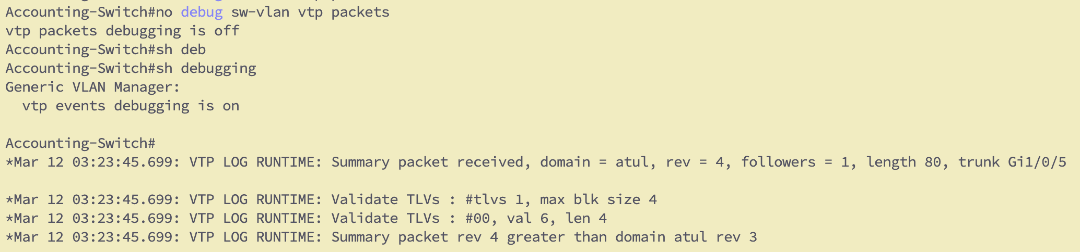

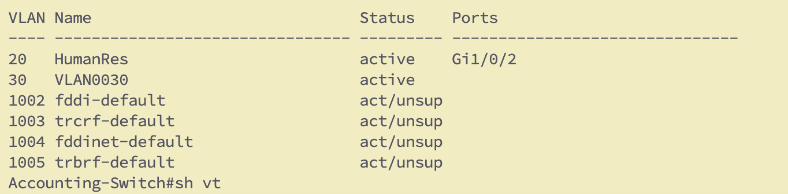

* + Connect a new Client name it as “Archive” to the Accounting-Switch in VLAN-30
  + Ensure proper reachability to its default gateway Gateway30.

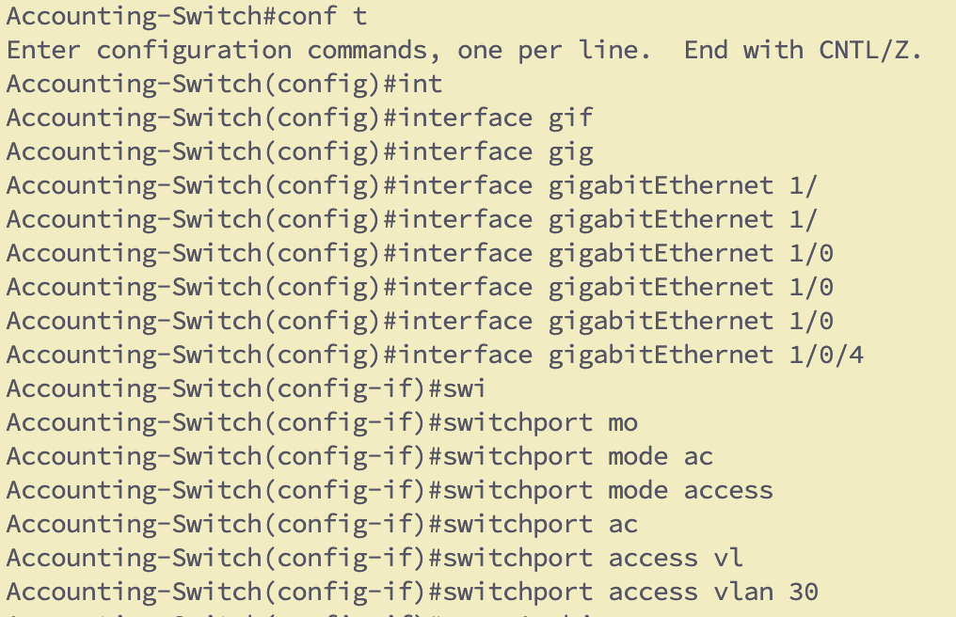

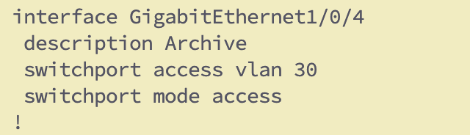

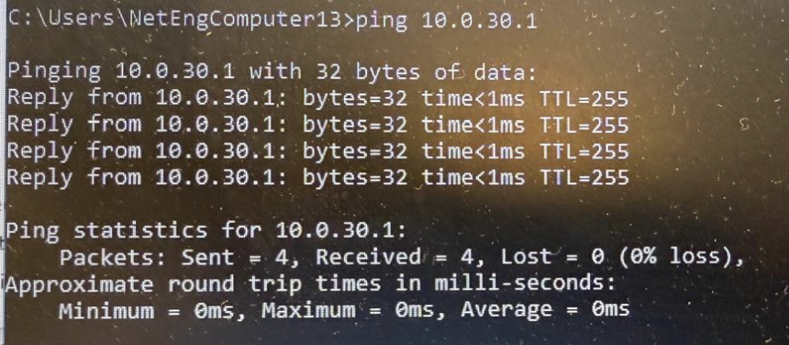

**MAKE SURE TO SAVE YOUR CONFIGS BEFORE ADDING NEW NODES**

Report the commands used for VTP versions, mode, domain, security and pruning + screenshots of the debug messages and the show results.

* show vtp counters  
* show vtp status

OUTCOME: Understand the different roles of VTP, understand how changes are propagated automatically by this feature, and what must be manually configured.

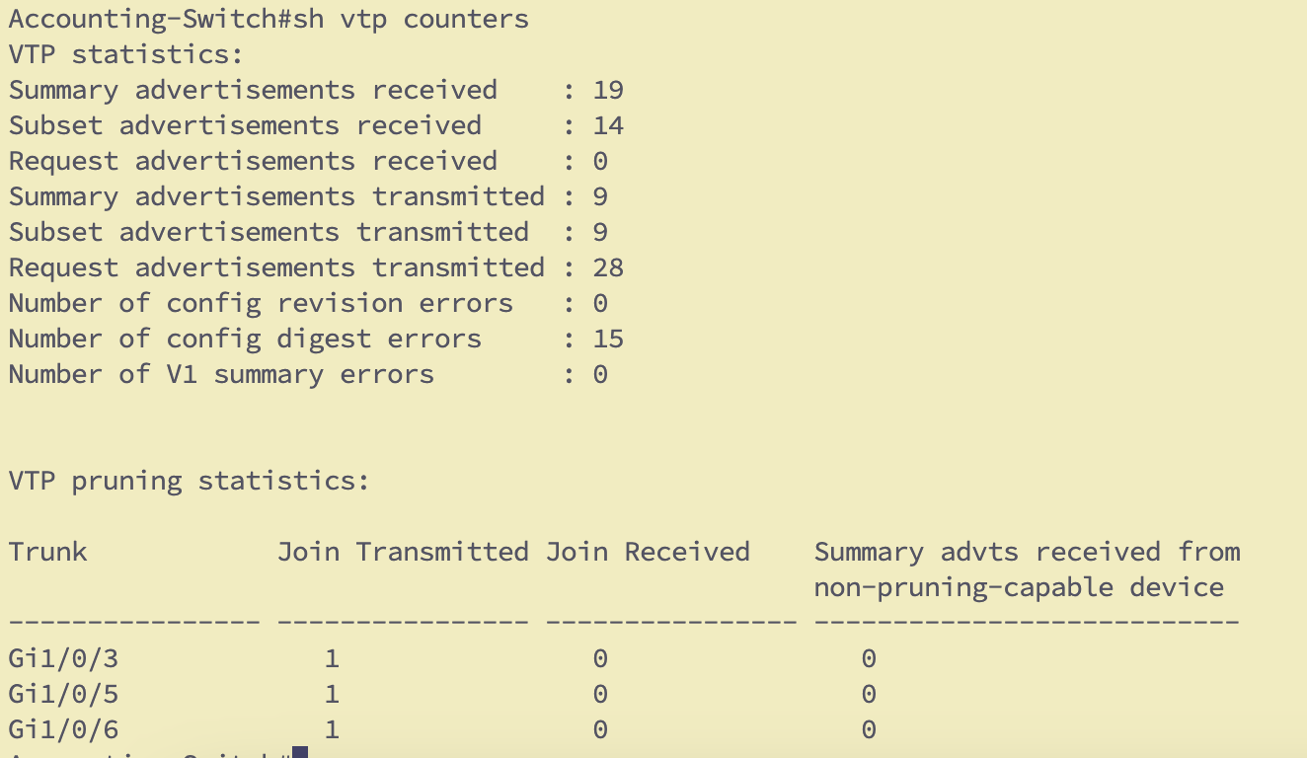

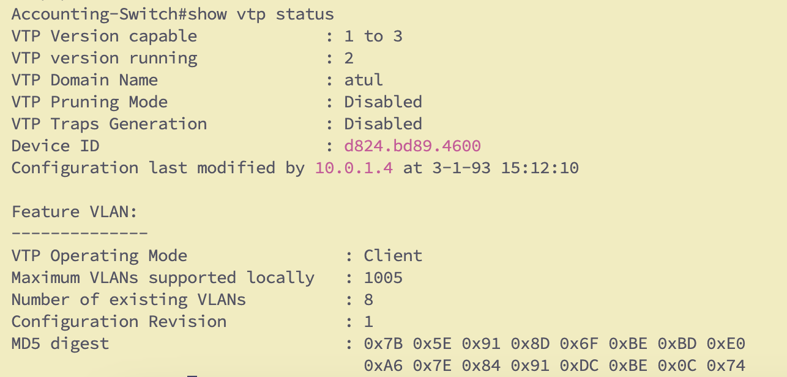

6.1 MULTI-HOP Routing

* + Make configuration needed for Archive client to ping all other systems and the FileServer (via its respective default gateway) NOTE that Engineeirng and accounting make use of Gateway1020 for their traffic, while Archive uses Gateway30 for its connectivity. (HINT: use static routes)
  + Add in your report 2 diagrams explaining how packets travel from Engineering to Accounting, and from Archive to Either one of them.

**Vlan 30 to VLAN 20 ping -**

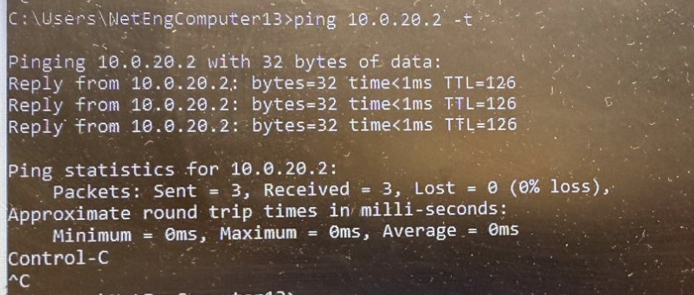

**Vlan 20 to VLAN 30 ping -**

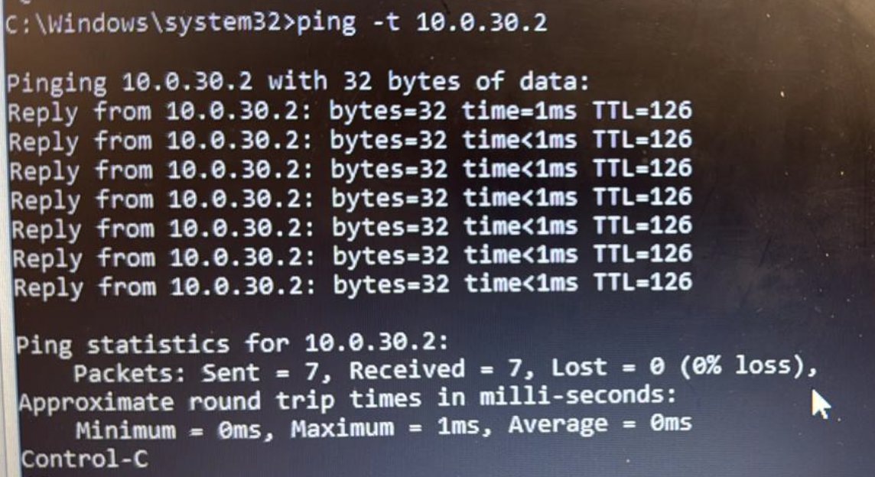

* + OUTCOME: Understand the need for a routing table to reach remote networks beyond default-gateway connectivity.

**Packet Travel from Engineering to Accounting**

Here, I am Assuming we are talking about different VLAN between those two switches





**Packet Travel from Archive to Engineering or Accounting:-**

Here I have connected Archive to Accounting switch but it is in VLAN 30 so it goes to Gateway 30 and then reaches gateway 1020 and then it is routed towards any client on respectrive VLANS





1. **Spanning Tree Protocol (STP) Configuration:**

Keep “debug spanning-tree bpdu” and “debug spanning-tree switch” ON on the core switch. Explain the messages generated from these commands when the topology changes.

* + Use “show spanning tree” command on each switch and locate any ports that are blocked by STP to prevent loops. Review the packet flow diagrams you created in the last objective and confirm exactly which ports/interfaces are being used by data flows.

Engineering-Switch –(Root Switch for all VLANS)

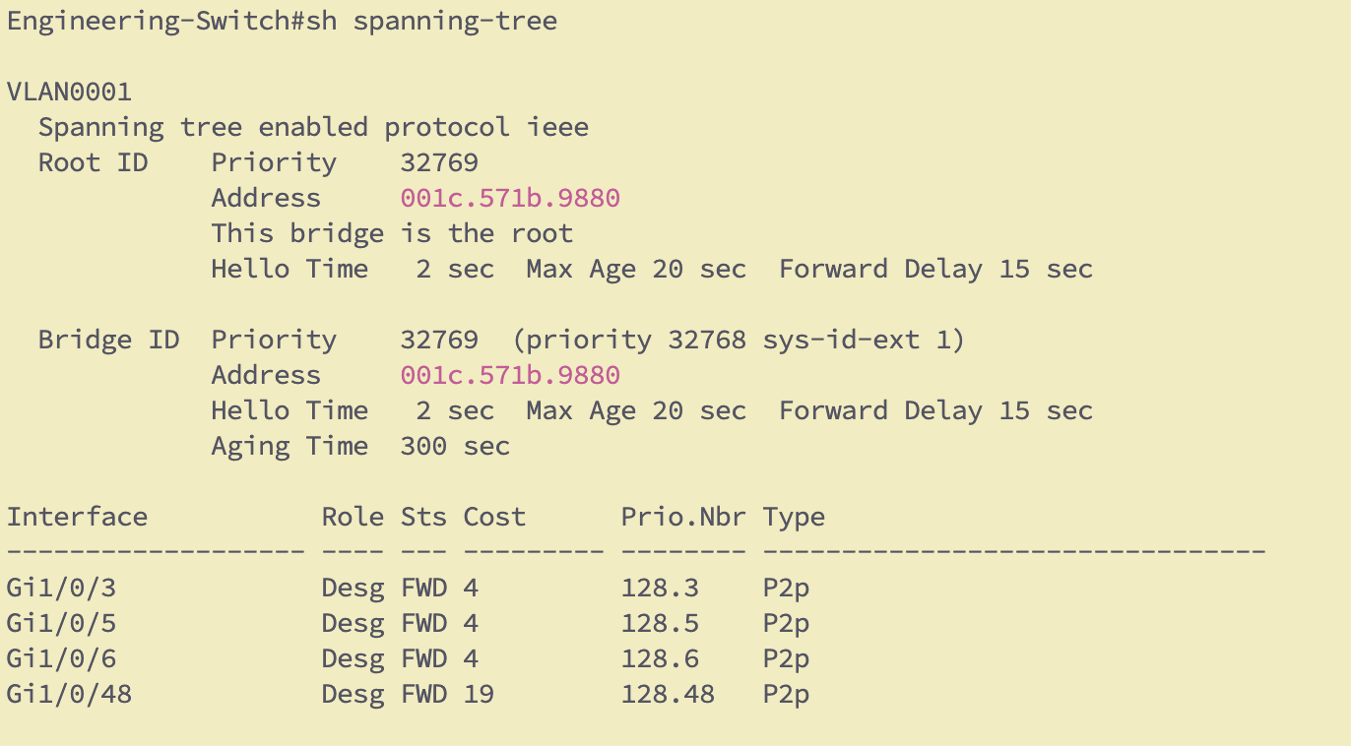

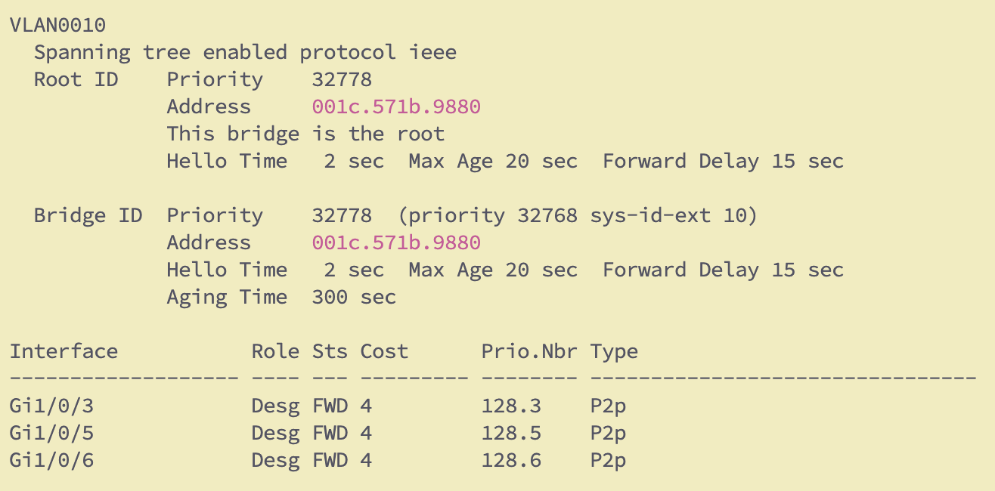

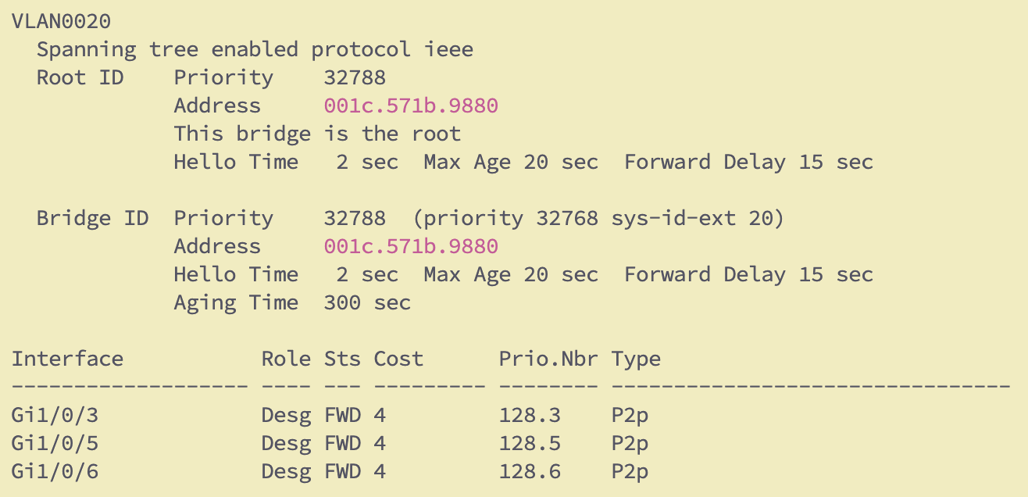

Accounting-Switch() -

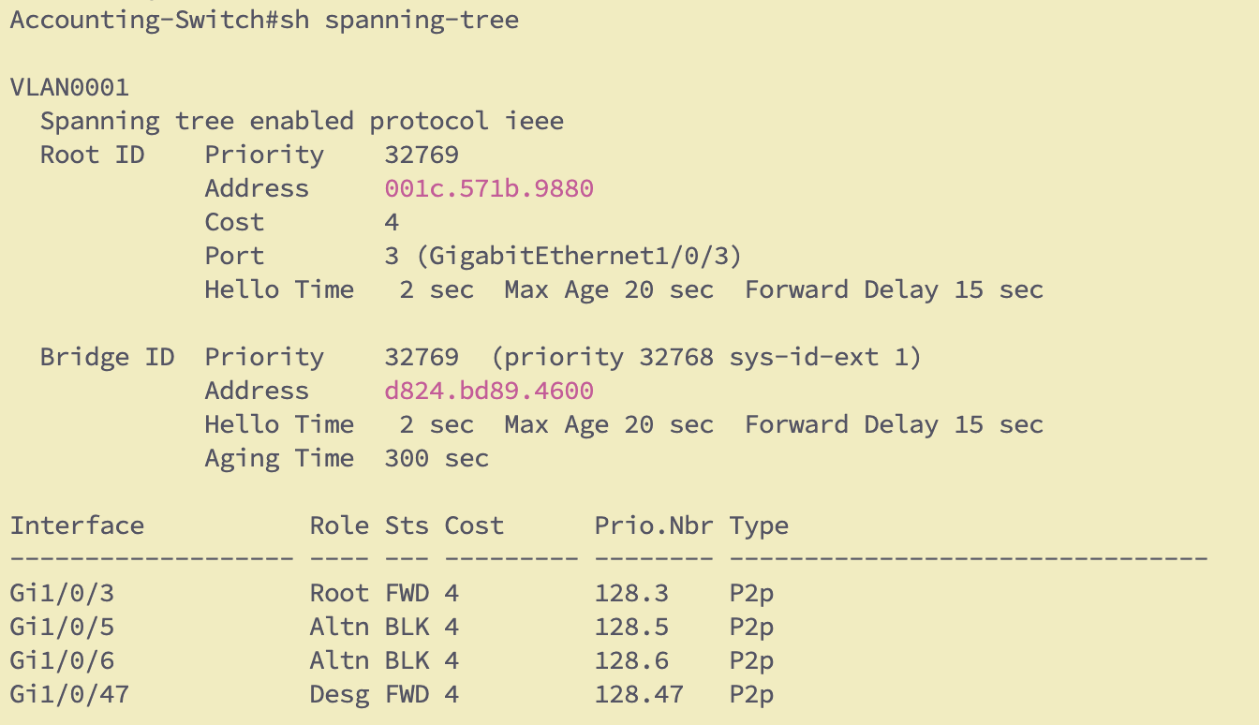

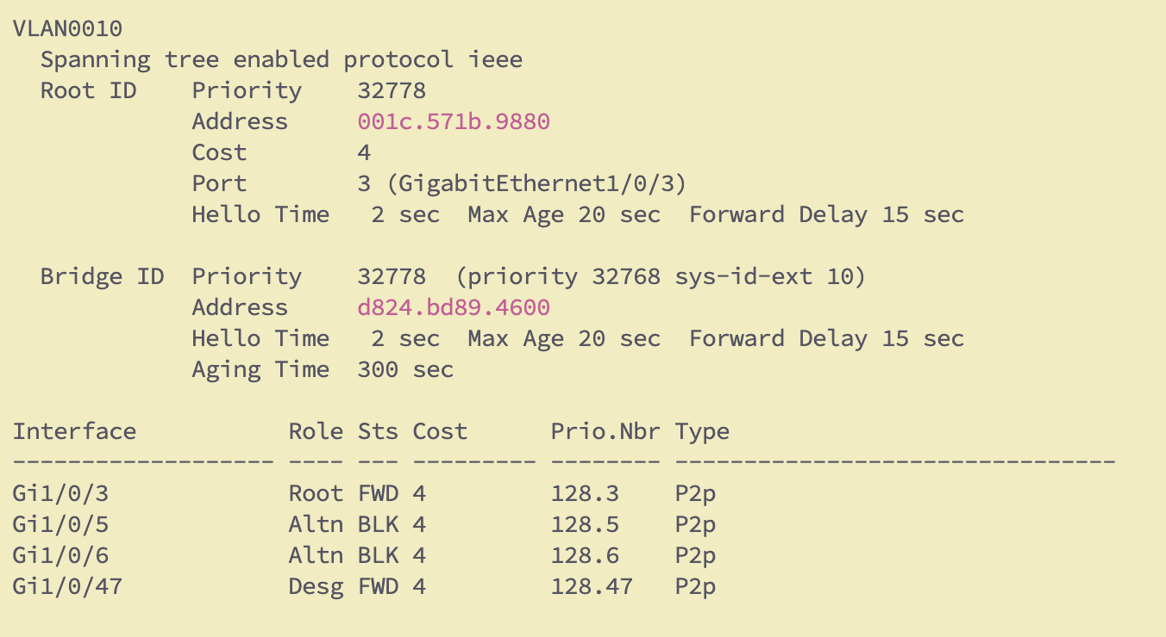

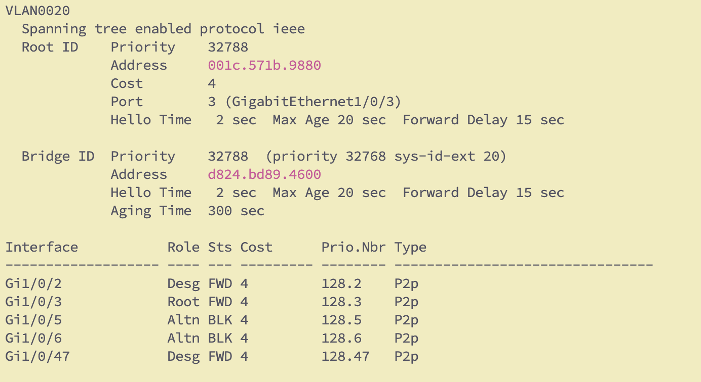

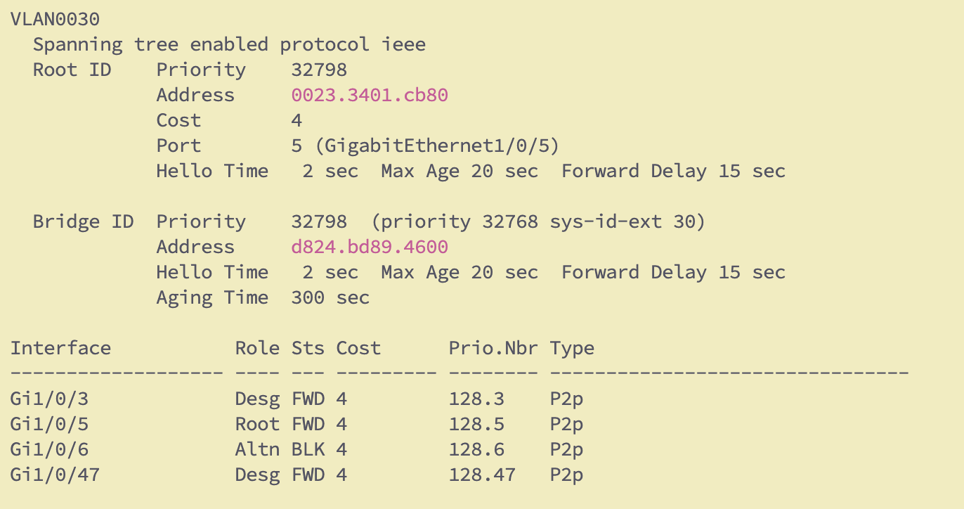

Core-Switch –

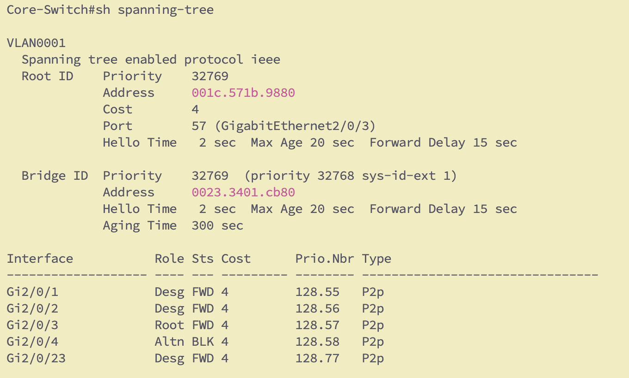

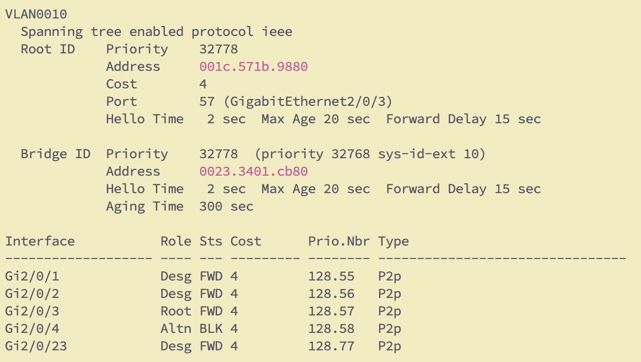

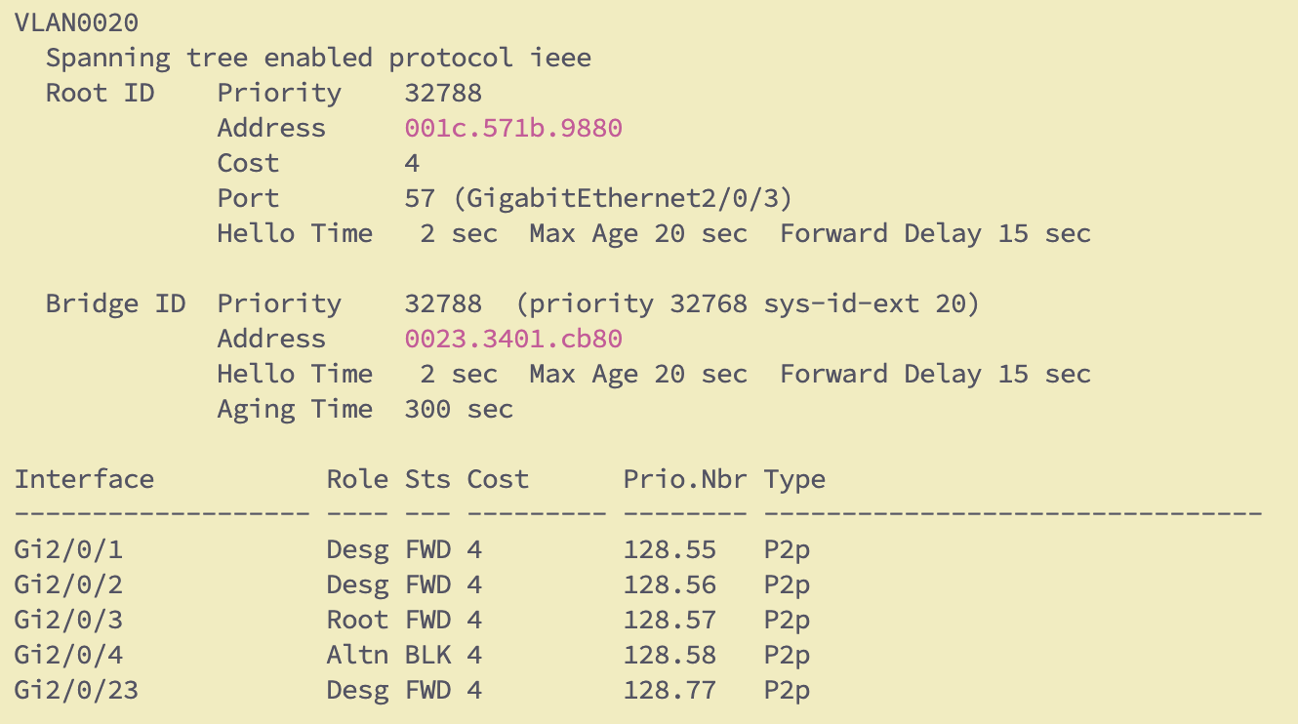

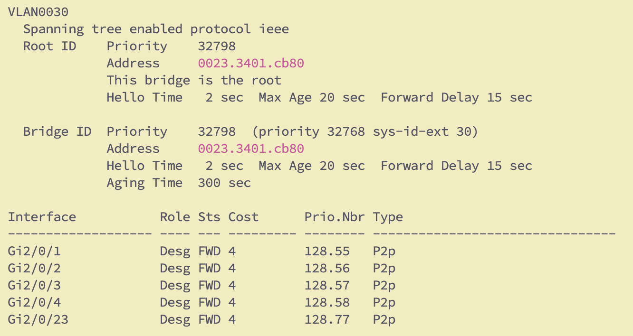

* + Identify and document the priority, root bridge, designated, root, forwarding and blocked ports on the three switches, for each respective VLAN.

Ans - Currently, **Engineering-Switch** is the root bridge for the VLAN 1, 10,20 and **Core Switch** is Root bridge for VLAN 30.

All the ports on the Root bridge are designated and port 3 on accounting switch is root port for VLAN 1,10,20.

The blocked ports are the redundant links connected to Core Switch from Accounting Switch which is port 5 and 6 going to core switch port 1 and 2

The link from Engineering-SW port 5 and 6 is connected to port 3 and 4 on core switch out which port 3 is root towards the EN-SW and port 4 is blocked.

Include screenshots of the show commands used to document this

* + Change the cost of the path in such way that traffic from Accounting-A follows the following path to reach the Fileserver. Change VLAN configs on the switches whenever needed.   
      
    Accounting-A 🡪 Accounting-Switch 🡪 Engineering-Switch 🡪 Core Switch 🡪 Gateway1020 🡪 Fileserver

Ans – Accounting A host is in VLAN 20 -Below diagram shows the hops taken by packet to reach the Gateway for VLAN 20 – once reached the gateway – it can reach the file server.

5c26.0a24.8ec5 – belongs to Host attached as Accounting A on the Accounting switch interface 2

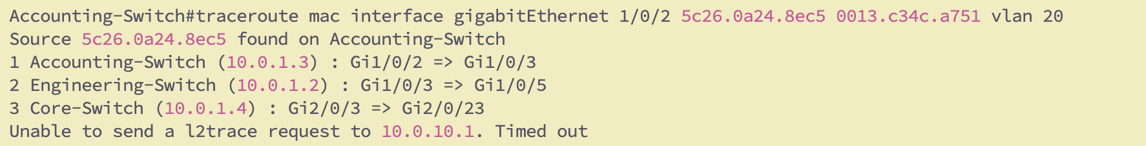

* + Change the cost of the path in such way that traffic from Engineering-A follows the following path to reach the Fileserver. Change VLAN configs on the switches whenever needed.   
      
    Engineering-A 🡪 Engineering-Switch 🡪 Accounting-Switch 🡪 Core-Switch 🡪Gateway1020 🡪 Fileserver

Cost change per vlan priority assigned to STP on Accounting to make it the root for vlan 10

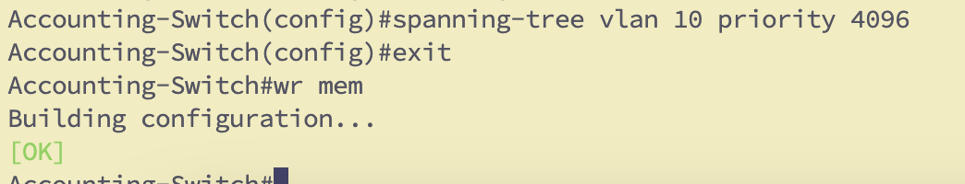

Ans - Engineering-A host is in VLAN 10 –and after the priority change on the Accounting for Vlan 10.

I could verify the packets taking above path to reach file server.

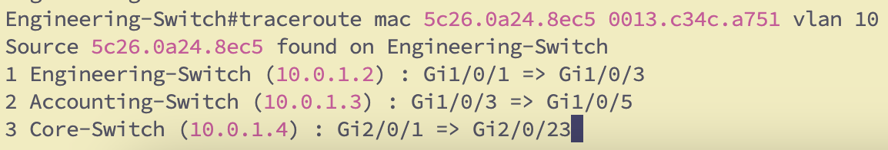

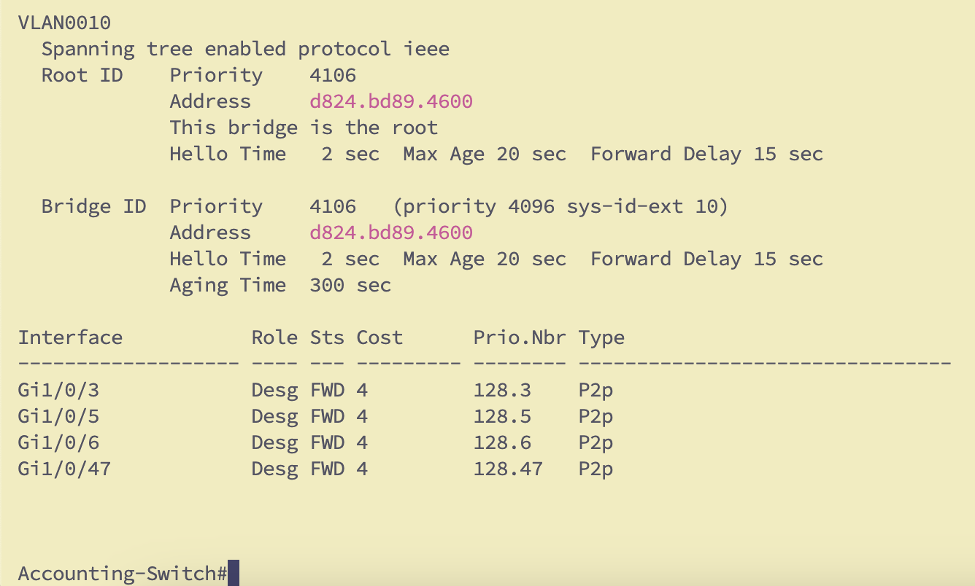

* + Use appropriate commands to replace the root bridge for another of your preference, make sure each VLAN has a different root switch.

The root for Vlan 20 is Engineering Sw and VLAN 10 is accounting, and core switch is for VLAN 30.

We had to change the vlan priority in accounting switch to achieve this.

* + Shut down one of the ports that connects your Root Bridge to another Switch on a particular VLAN (in forwarding state), document how the backup port transitions from Blocking to Forwarding.

I choose VLAN 30 and shutdown the port 5 which was root port and forwarding state.

We could capture the debug messages for link state change as screenshot below

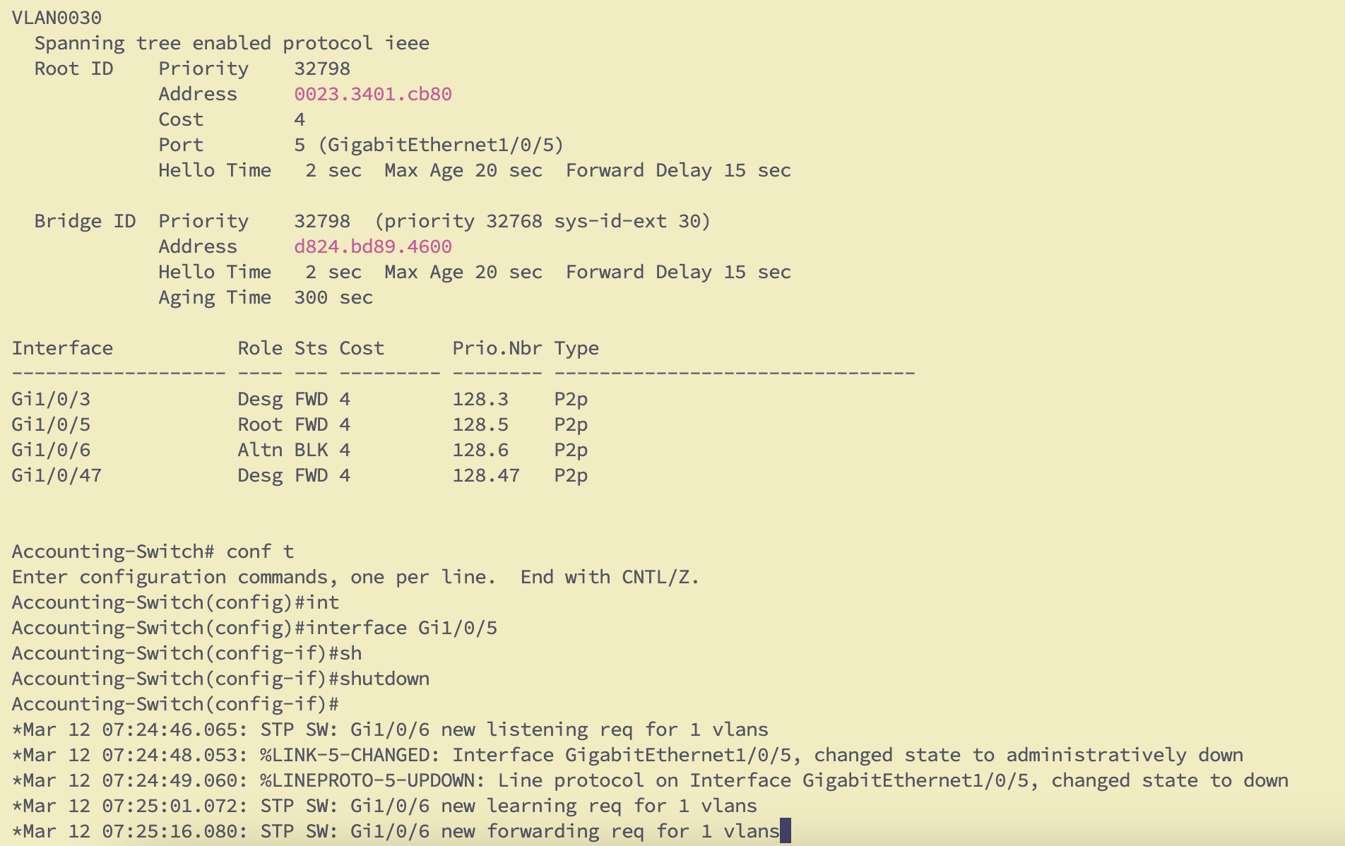

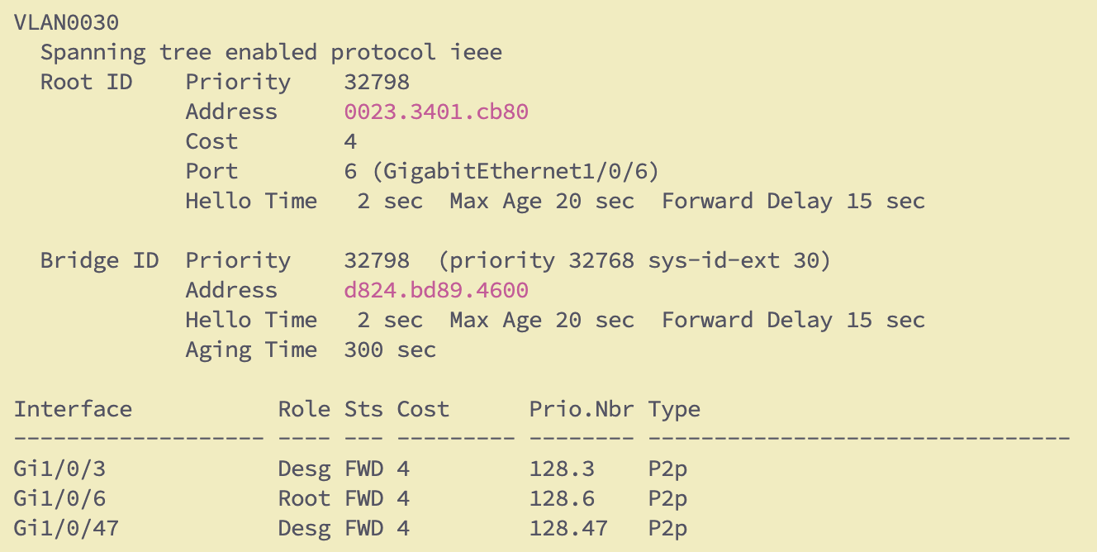

* + How long does it take STP to re-converge (Report)?

In this Setup, we are running PVST so The total time take to reconverge from failure to change the port state is **37** seconds.

* + Stop the DEBUG once done. (NOTE if using a virtual lab tool, this might not show intermediate steps)

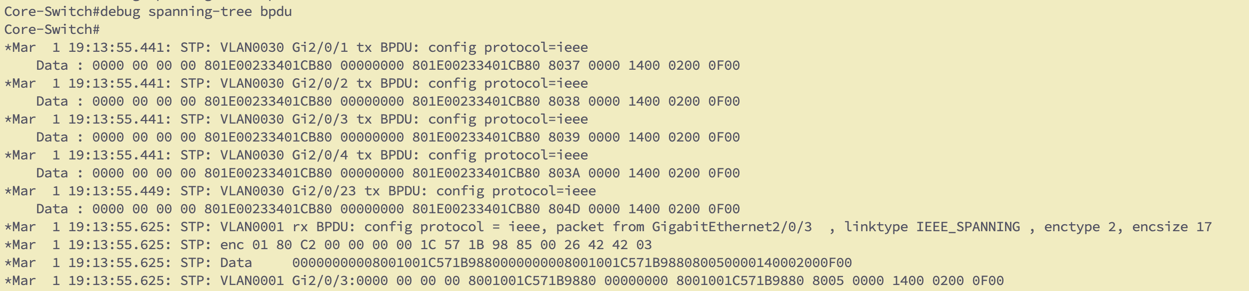

1. **RSTP**:   
     
   STP has disadvantage that it has low convergence which is important at layer 2 LAN. IEEE with document 802.1W introduced an evolution of spanning tree protocol: Rapid Spanning Tree Protocol (RSTP), which reduces the convergence time after a topology change occurs in the network. STP takes 30 to 50 seconds from transit from blocking state to forwarding state. RSTP usually responds less than 10 seconds of a physical link failure.
   * Enable Rapid Spanning Tree Protocol (RSTP) for faster convergence.

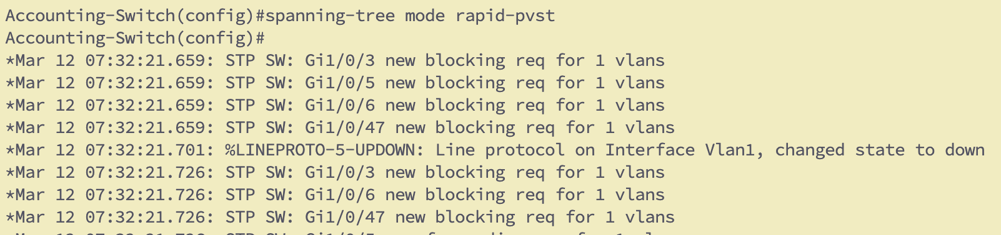

* + Shut down one of the ports that connects your Root Bridge to another Switch, report how long does it take RSTP to re-converge (Report) Stop the debug commands

I performed the same operation for VLAN 30 and shut the port 5 after enabling the Rapid PVST.

It took me around 3 seconds the port 6 changed from alt blk to forwarding.

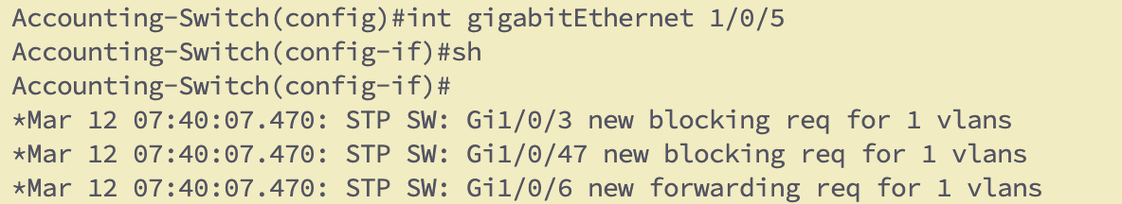

Turn on debugging for spanning-tree and report the show command results and the differences.

The difference is observed is significant as it cuts down substantial amount of time.

References: [http://www.cisco.com/c/en/us/support/docs/lan-switching/spanning-tree- protocol/24062146.html](http://www.cisco.com/c/en/us/support/docs/lan-switching/spanning-tree-%20protocol/24062146.html)

Report the commands you used for configuring and manipulating spanning-tree.

OUTCOME: Learn how STP works by default, how to manipulate root role and path selection. Understand STP auto- convergence.

1. **Enhancing Network Efficiency with EtherChannel by overriding STP blockage between devices:**
   * You are facing congestion problems on your uplinks to the core switch, configure EtherChannel on the uplinks between the two Switches and the core switch to increase network capacity and redundancy. Configure E1 with PAGP and E2 with LACP.

E1(Engineering Switch to Core Switch) –

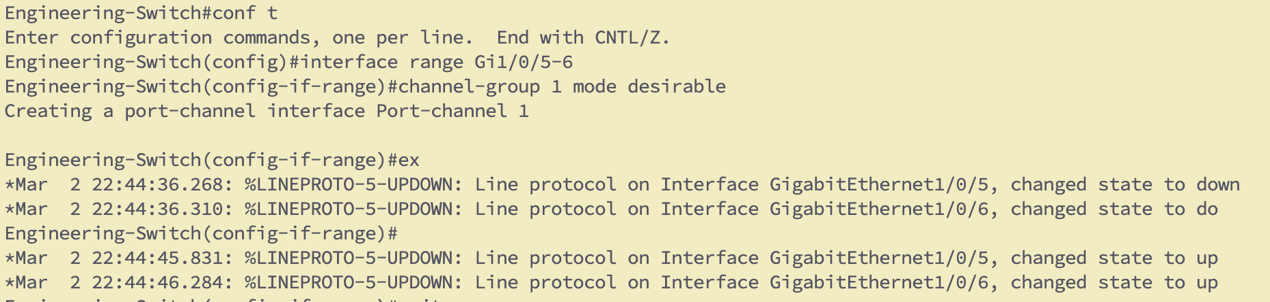

Once configured the Cor-Switch Port 3 and 4 the Port-channel come up –



E1(Accounting Switch to Core Switch) –

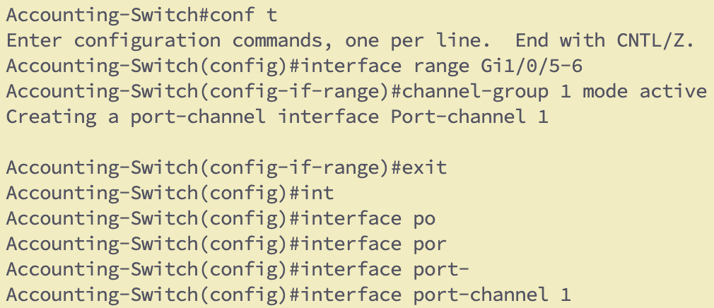

* + Verify that STP treats the EtherChannel as a single logical link. Once you implement Etherchannel correctly you should not see a blocking port between Core switch and its neighbors

**E1** - We could verify now Po1 shows up as single unit for both the interfaces –

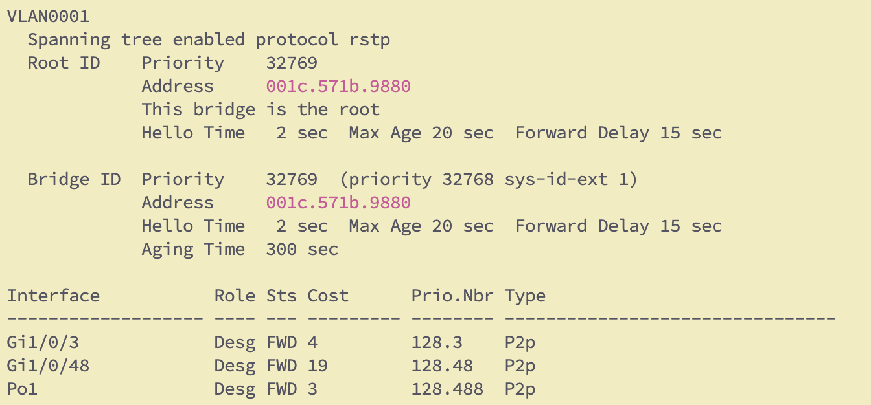

E2 –

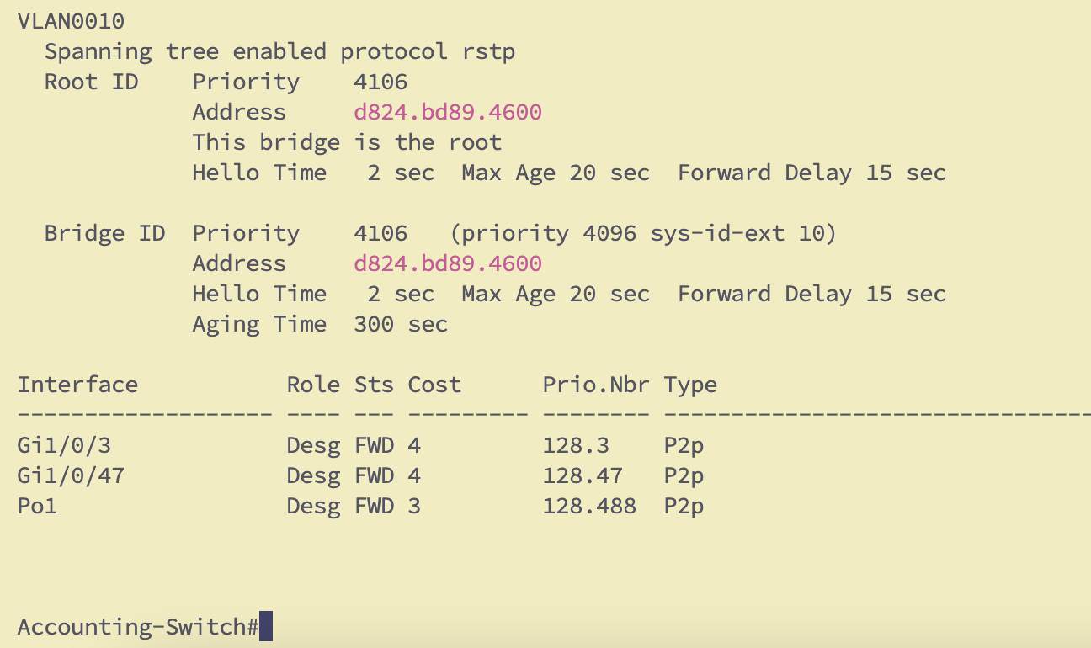

* + Assure that data flow for engineering and accounting over the switches still follows the paths defined before. Adjust as necessary to restore it (if needed)

Verified and same root and same path for all the VLANs

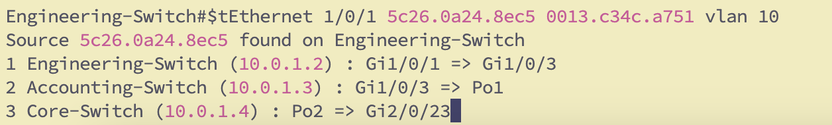

9.1 STP Stability with Etherchannel

* + Test the network by disconnecting one of the EtherChannel member links and observing whether STP reconverges or not.

No, As both the ports as considered one single unit by STP so it does not detect the change.

* + Explain the difference between STP cost, port speed and bandwidth on an ethernet switch. Which of these features was useful to you for this objective? Where are the other ones used?

I used the priority of the switch which is used as cost to determine the root to affect traffic direction.

* + OUTCOME: Etherchannel (EC) configuration via 2 different protocols, and the effects of EC over STP.

**E1 using PAgP –**

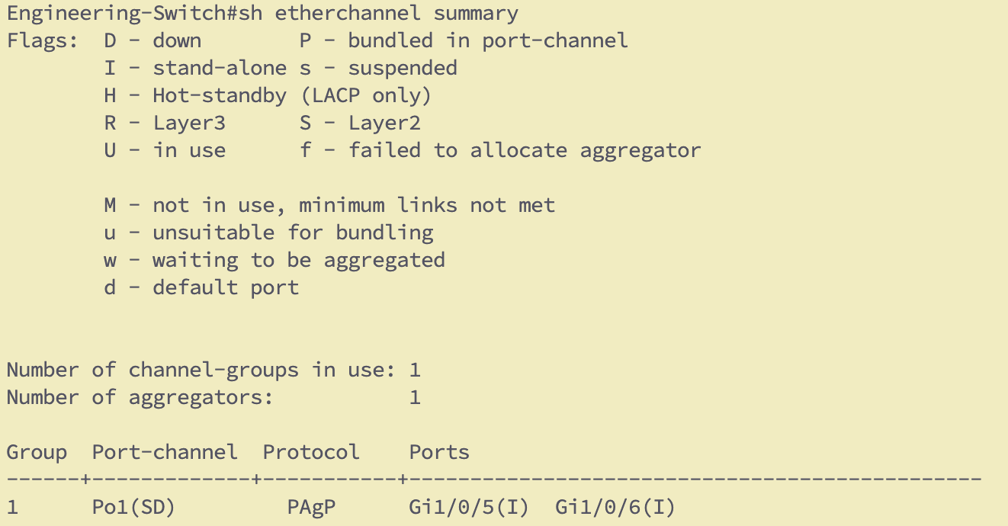

**E2 using LACP**

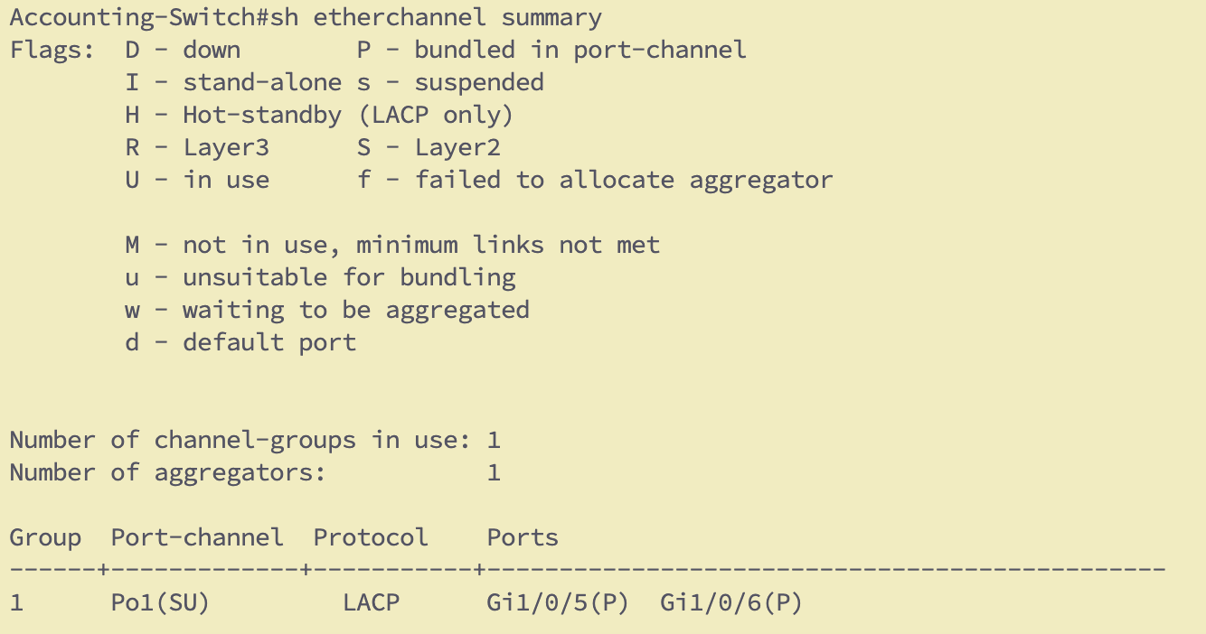

1. **PortFast**

What are the advantages of portfast?

PortFast allows end devices to connect faster by bypassing STP delays.

Enable portfast on one of the ports on which one of the clients is connected

Verify the change in response time. Give a snapshot of the debug command used and explain what you see in it.  
** This part might not be doable on the virtual lab. Just report the commands you used for configuring portfast**

Without Portfast –

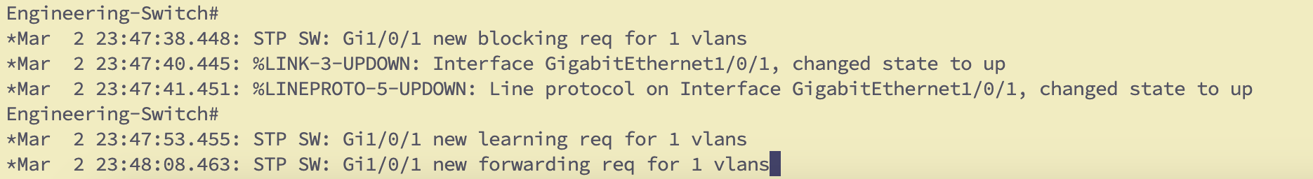

We can see state transition messages on the port in above screenshot as it goes through all the phases of STP which take around 30 to 50 seconds before port can start forwarding.

Port fast enabled –

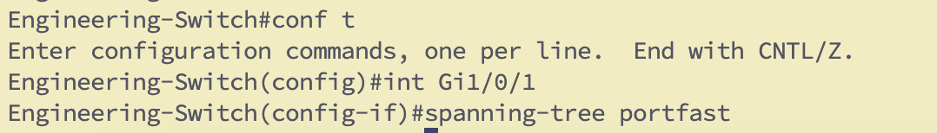

As soon as Portfast is enabled, and port is bounced it immediately turns to forwarding in couple of seconds as evident by screenshot and debug messages.

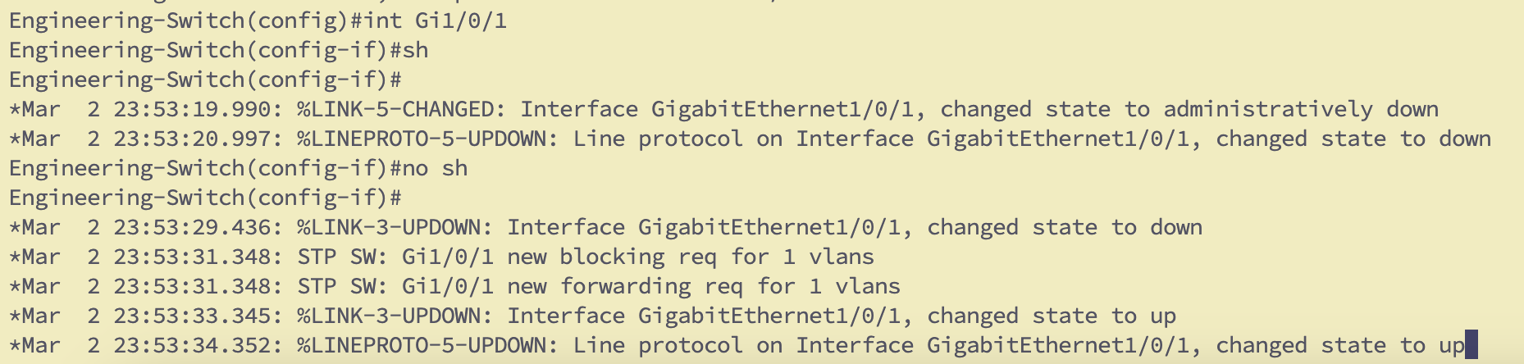

1. **Configuring SPAN for Packet Sniffing:**
   * Configure SPAN on Engineering switch, so it can capture the traffic exchanged between all users and send it to the Sniffer System.
   * What does SPAN do? Why is this capability provided?

SPAN (Switched Port Analyzer) is used to mirror traffic from one or more switch ports to a specific destination port for monitoring. This helps network admins analyze traffic for troubleshooting, security, or performance.

* + Set up a SPAN session on one of the switches to mirror traffic from a department’s VLAN.

VLAN 10

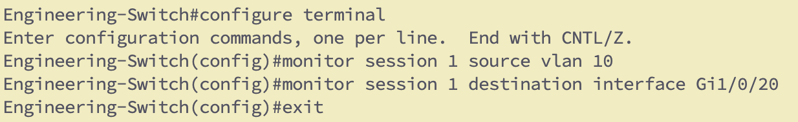

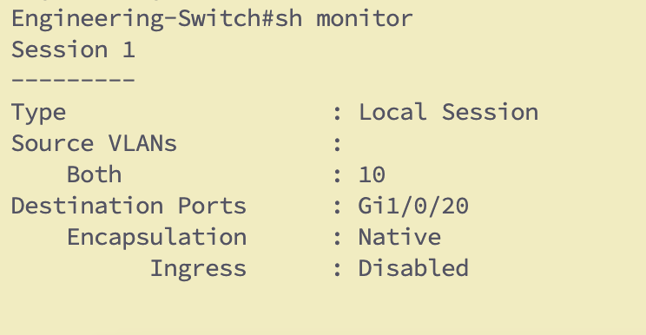

* + Use Wireshark or TCPDump to capture and analyze packets.

I was able to capture icmp packets from VLAN 10 host pinging its gateway on port 1 by sending it to port 20 on Switch 1.

* + Add to your report a snippet of packets captured.

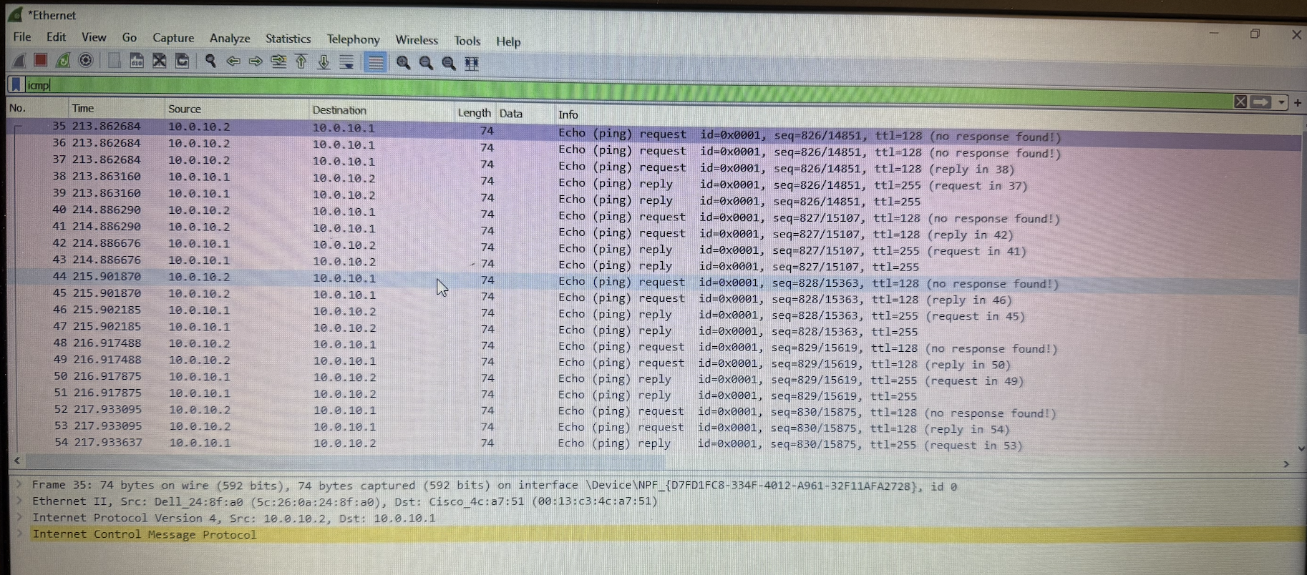

**Report Questions (answer after the questions):**

* + 1. How would you secure a switch to prevent others from accessing the network? (Hint: think layers)

Ans – We can use VLAN, and port-security combined to limit the who can access the port in terms of devices and expected behavior.

This can be further enhanced by locking down the management access by using SSH.

* + 1. What is the length of the MAC address? How is it divided?

A MAC address is 48 bits long, divided into two 24-bit parts: the Organizationally Unique Identifier (OUI) and the Device Identifier (NIC-specific).

* + 1. Are sticky ports secure? Why or why not? Is it recommended?

Sticky ports provide basic security by learning and binding MAC addresses to a port, but they are not entirely secure because attackers can spoof MAC addresses. They are recommended for small-scale environments or as part of a layered security approach, but additional measures like 802.1X are advised for stronger protection.

* + 1. Why are switches faster than routers?

The forwarding decisions are made by hardware which ensures faster processing as there is minimal to no serial delay.

The decision by routers is made in software which adds to the serial delay where router has to process the data and then route the packet.

* + 1. How many MAC addresses does your computer have? How do you find out?

My computer has two macs address i.e one for ethernet and one for WiFi NIC cards.

We can find the mac addresses by using the terminal and ifconfig or ipconfig /all depending on the OS of the computer.

* + 1. What problem is portfast meant to solve in a network?

Usually, when we connect the PC to port on computer, The port by default participates in STP which causes delay in terms of connectivity as port has to go through the STP states like Blocking, Listening, Learning and Forwarding.

The Port fast command solves this problem by assuming the user will be connecting an endpoint like Laptops and skips the learning and listening stages making it nearly instantaneous to allow connectivity for devices (3 seconds)

* + 1. Can you change your MAC address? If so, how?

The physical MAC address is hardware dependent and is stored on the NIC's ROM (EEPROM) chip. To physically change this, you would have to do what is known as flashing the ROM chip on the NIC.

However, we can spoof the MAC Address of the machine by registry editing on Windows.

1. Name/explain other applications of SPAN (Why do we need port replication/monitoring services for?)

SPAN (Switched Port Analyzer) is used to monitor and analyze network traffic by replicating packets to a monitoring device. Applications include diagnosing network issues, intrusion detection/prevention, traffic analysis, and ensuring regulatory compliance. It also helps in performance monitoring and forensic investigations to identify unauthorized activities or optimize network performance.

1. What are the advantages of using VLANs?

VLANS separate the broadcast domain and are like Independent MAC address table for each segment.

It provides much needed segmentation to break down the broadcast domain to small and manageable chunks.

1. Tell me any disadvantages of using VLANs

VLANs can add complexity to network management, requiring proper configuration to avoid issues

1. Can you do trunking with a PC? Is this a popular practice?

Yes, trunking can be done with a PC by configuring its network interface to support VLAN tagging (e.g., using software like vconfig on Linux). However, it is not a popular practice as PCs typically connect to access ports rather than trunks. Trunking is more common with servers or network devices requiring access to multiple VLANs.

1. Can you telnet into a switch? Can any PC on any VLAN telnet into a switch (assume all PCs are connected to the same switch)?

If we configure the transport local input to accept the telnet, we can telnet to PC.

The Telnet requires IP connectivity and will only work from PC which is part of same VLAN and has IP connectivity else we would need to configure SVI and enable InterVlan routing to ensure all VLANS can login to switch

1. Why do we need a Native VLAN for?

The Native VLAN is used to carry untagged traffic on trunk links, often designated for management or control traffic.

1. Give any important details regarding native VLANs in 802.1Q trunking.

In 802.1Q trunking, the Native VLAN carries untagged traffic and is typically used for management or control traffic. By default, VLAN 1 is the Native VLAN, but it is recommended to change it for security reasons.

1. Find and explain other trunking services used in industry.

IEEE 802.1Q: The most common standard for VLAN tagging in trunk links, inserting a 4-byte tag into Ethernet frames to indicate VLAN membership.

ISL (Inter-Switch Link): A proprietary Cisco trunking protocol, which also tags frames with VLAN information, but is being phased out in favor of 802.1Q.

1. What is a multilayer switch?

A multilayer switch is a type of switch that can work like both a regular switch and a router. It switches data within the same network (Layer 2) and can also route data between different networks or VLANs (Layer 3), making it faster and more efficient for large networks.

1. Explain how is RSTP better than STP?

RSTP (Rapid Spanning Tree Protocol) is faster than STP (Spanning Tree Protocol) because it reduces the time taken to detect and recover from network failures, providing quicker convergence and less downtime.

1. What is the advantage of having Per VLAN STP? Explain VTP VLAN pruning.

Per VLAN STP (PVST) allows each VLAN to have its own independent spanning tree, improving network efficiency, better link management, and utilization by reducing the chance of blocking traffic across VLANs.

VTP VLAN pruning optimizes network resources by disabling unused VLANs on switches, leading to better management and more efficient utilization of links, while also saving bandwidth.

1. Why do we need a Native VLAN for?
2. Give any important details regarding native VLANs in 802.1Q trunking.
3. Find and explain other trunking services used in industry.
4. What is a multilayer switch? What internal processing has to happen inside the switch (to the packet) in order to be able to do forward data based on layer 3 information?

A multilayer switch can perform both switching (Layer 2) and routing (Layer 3) functions.

To forward data based on Layer 3 information, the switch needs to examine the destination IP address in the packet, consult its routing table, and then forward the packet to the correct port based on the routing decision.

1. Explain how RSTP is better than STP